|  | **FPT ACADEMY INTERNATIONAL**  **FPT – APTECH COMPUTER EDUCATION** |
| --- | --- |

**Centre Name: ACE-HCMC-2-FPT.**

**Address: 590 Cach Mang Thang 8, District 3, Ho Chi Minh City, Viet Nam.**

**[National Park]**

| **Supervisor:** | Phạm Thị Lánh | |
| --- | --- | --- |
| **Term:** | 1 | |
| **Batch No:** | T1.2112.E0 | |
| **Group No:** | 4 | |
| **Order:** | **Full name** | **Roll No.** |
| 1. | Nguyễn Minh Quân |  |
| 2. | Trần Minh Hiếu |  |
| 3. | Hồ Hoàng Minh Quân |  |

**Content**

Content

Acknowledge

Synopsis

Site map

REVIEW 1

Website design layout

1. Homepage
2. Nation Park
   1. Animals
   2. Over view
   3. Plants
   4. Book Tickets
3. Thing to do
4. Visa requirement

REVIEW 2

Month 11 Year 2022

# **Acknowledge**

As we understand that the eProject is a step-by-step learning environment that closely simulates the classroom and Lab based learning environment into actual implementation. It is a project implementation at your fingertips!! An electronic, live juncture on the machine that allows you to.

✓ Practice step by step i.e., laddered approach.

✓ Build a larger, more robust application.

✓ Usage of certain utilities in applications designed by the user.

✓ Single program to unified code leading to a complete application.

✓ Learn implementation of concepts in a phased manner.

✓ Enhance skills and add value.

✓ Work on real life projects.

✓ Give a real-life scenario and help to create something more complicated and useful.

✓ Mentoring through email support.

We would like to send a great thank you to our professor and other students for the adorable support during the time in the project.

Beside several mistakes we had made in the project, we hope to have more opportunities to widen our knowledge in the web developing world.

We also thank you so much for your information and the “demo” project from India APTECH to help us get more reality experience in this project. Since we have gained more experience from this project, we will not stop learning anything as much as we can to be more successful in the future.

Your Sincerely,

Team Group 01.

# **Synopsis**

- The Objective of this program we aim is to give a sample project to work on real life projects. These applications help us build a larger, more robust application.

- The objective is not to teach us HTML/JavaScript but to provide us with a real life scenario and help us create basic applications using the tools.

- Hence, we can revise the chapters before we start with the project.

- This project The Objective of this program is to give a sample project to work on real life projects. These applications help you build a larger, more robust application.

- The objective is not to teach you the software but to provide you with a real-life scenario and help you create basic applications using the tools.

- You can revise the topics before you start with the project.

- This project is meant for students who have completed the module of HTML5.

- These programs should be done in the Lab sessions with assistance of the faculty if required.

- The website (in this project) is a tool that help the company to access the

international market and gain more and more new customers.

- It is very essential that a student has a clear understanding of the subject.

## **Problem Definition**

* The website helps tourists refer to the ecology of the national parks in Vietnam
* The website is to be developed for the Windows Platform using HTML5, JavaScript and Geolocation. The site should work well in all leading browsers including Chrome, IE, Firefox etc.

Here are some problems need to be resolved:

* Helping tourists to book sightseeing tickets online
* The website helps tourists get more information about the ecology of their favorite national park

## **Customer Requirements Specifications**

| USER: |
| --- |
| Input:  ● Enter visitor information  ● Send questions/requests to the company |
| Process:  ● Collect questions/requests sent by consumers |
| Output:  ● Reply to the consumer’s requests/questions |

| WEBMASTER: |
| --- |
| Input:  ● Control website database… |
| Process:  ● Analyse website |
| Output:  ● Website interface, images, forms, …  ● Giving interaction |

| HARDWARE / SOFTWARE REQUIREMENT: |
| --- |
| Software:  ● Notepad/HTML editor  ● Dreamweaver/Javascript |
| Hardware:  ● A minimum computer system that will help you access all the tools in the courses is a Pentium 166 or better  ● 64 Megabytes of RAM or better |

Site map

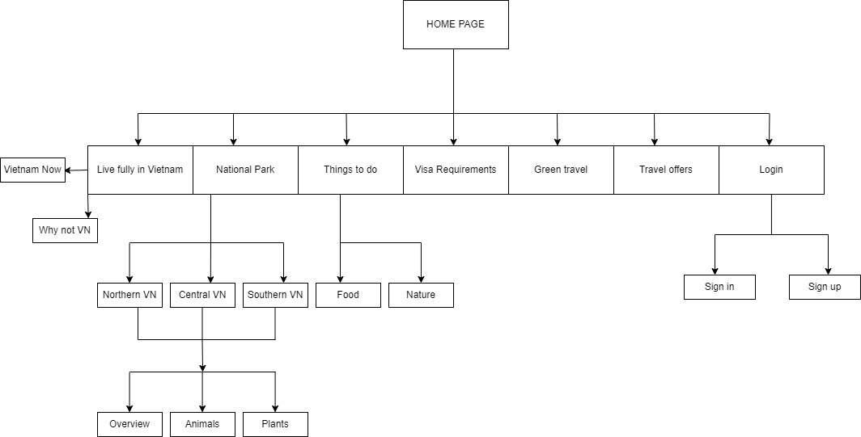

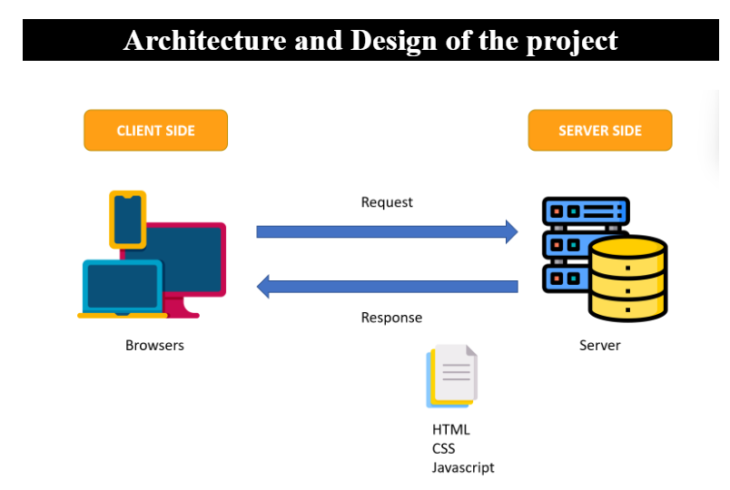

**REVIEW 1**

Website Design Layout

1. **Homepage**

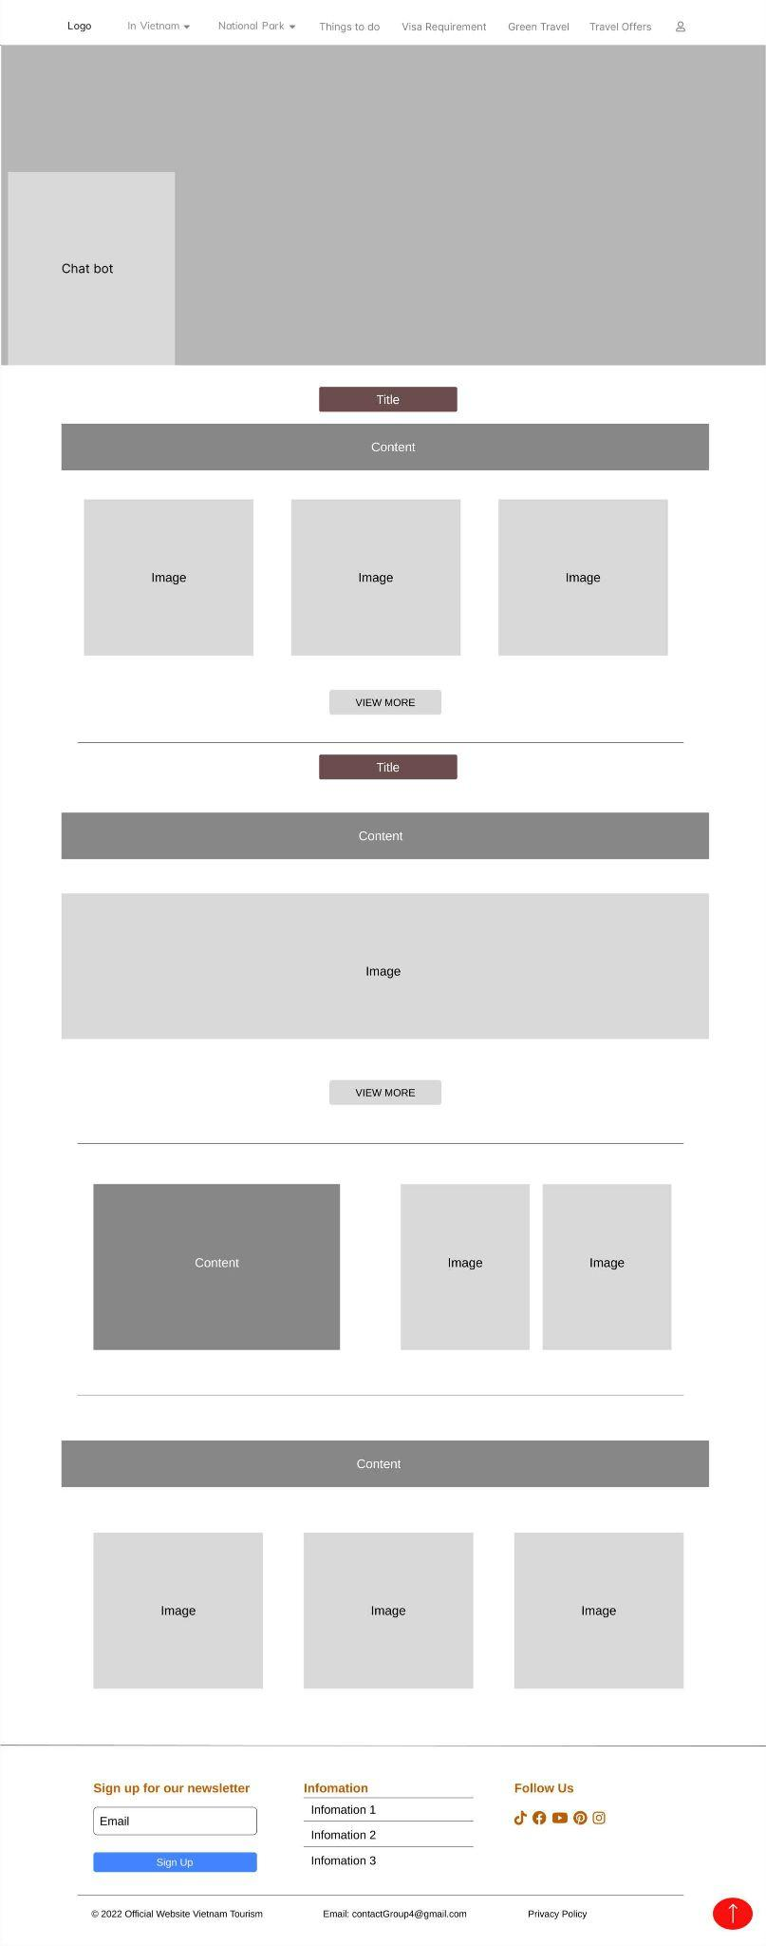



**Description:** The homepage of National Park. On top of the page, there’s the navigation bar that allows the user to navigate the site. The page consists of 3 main sections, each section containing different information about the National Park.

1. **National Park**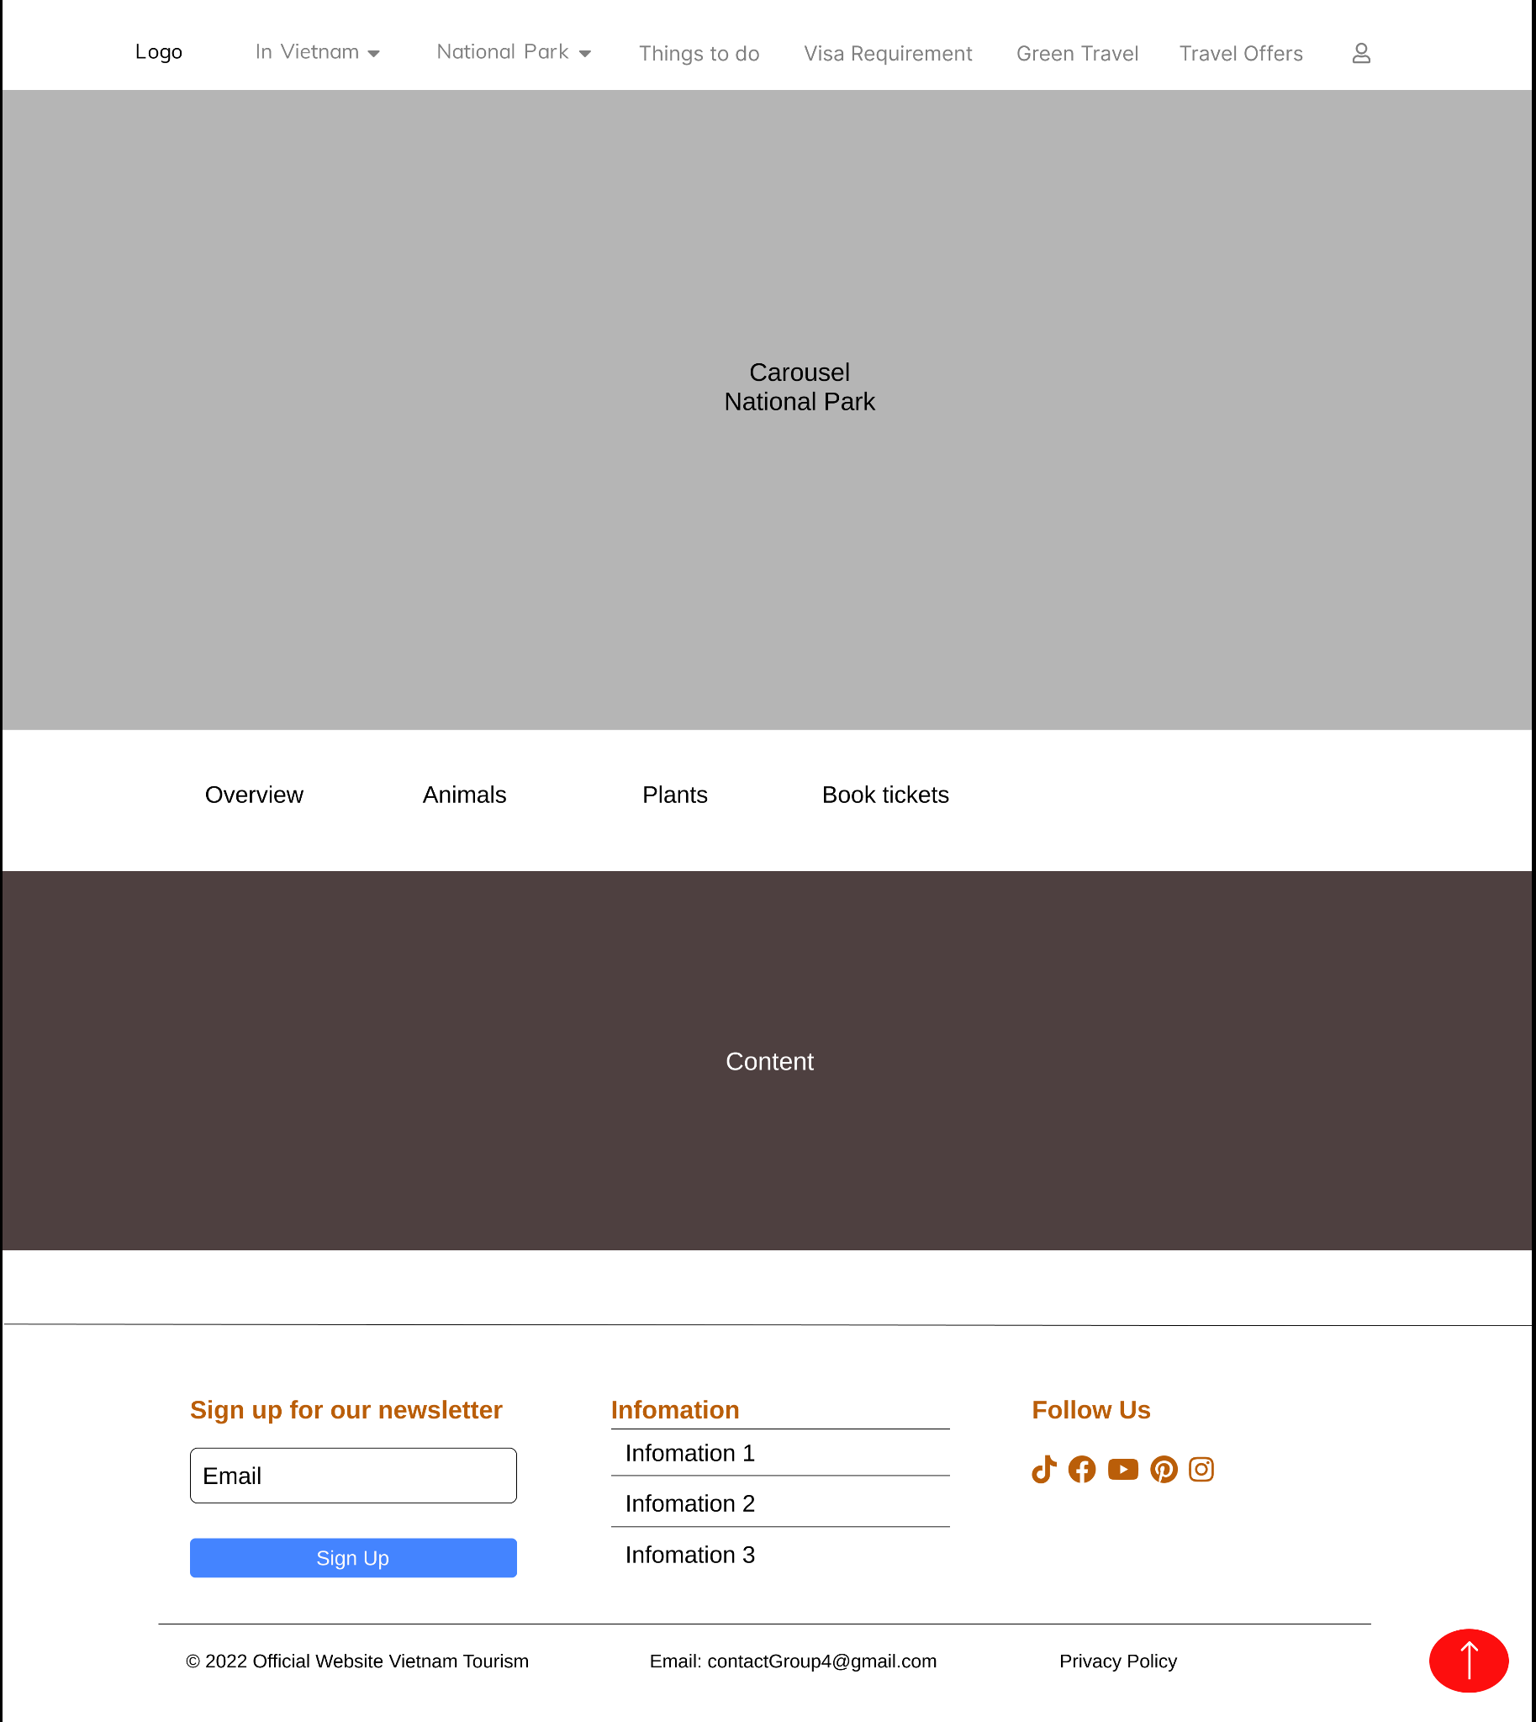

1. **Animals**

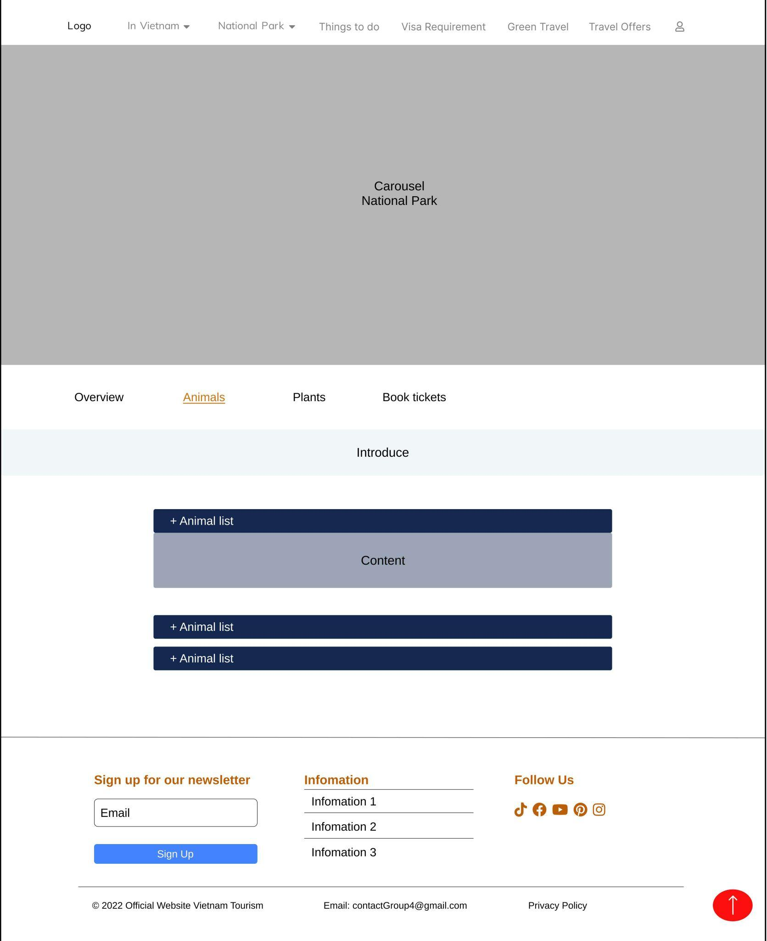

**Description:** When the user clicks on the “Animals” tag on the navigation bar, they will be directed to this page. The main part of this page contains 3 dropout list.

1. **Plants**

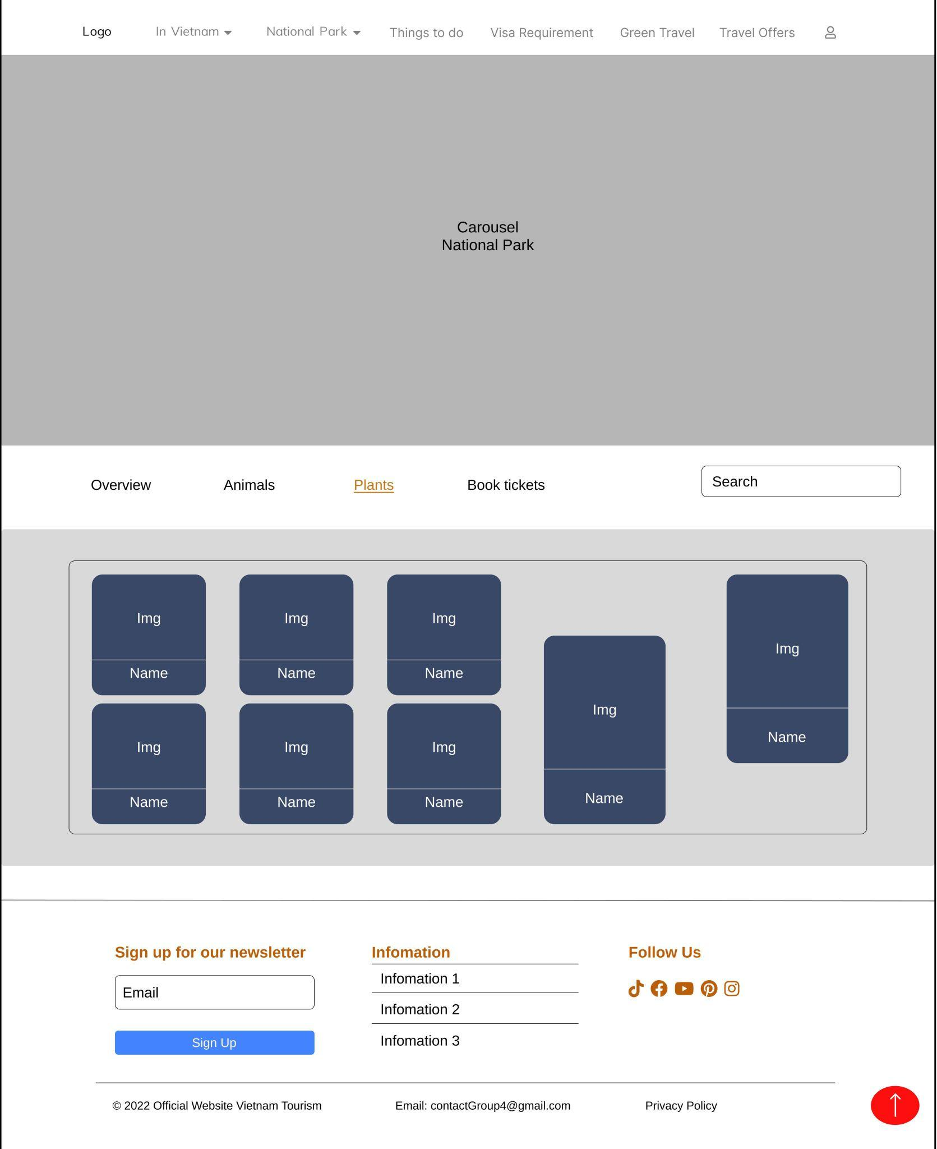

**Description:** When the user clicks on the “Plants” tag on the navigation bar, they will be directed to this page. This page contains images of different plants and their names.

1. **Book tickets**

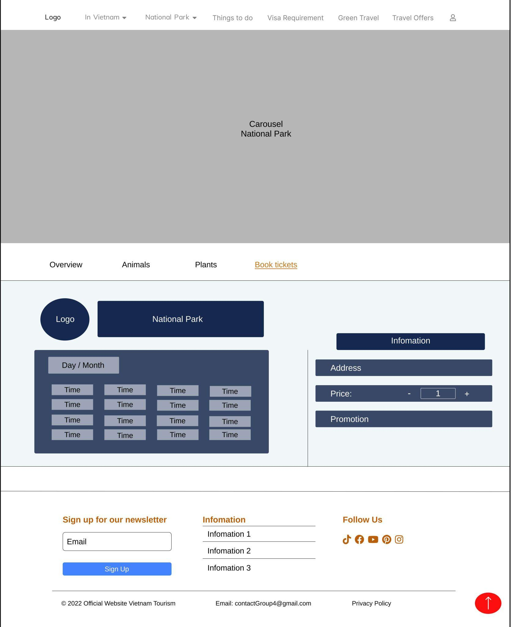

**Description:** When the user clicks on the “Book tickets” tag on the navigation bar, they will be directed to this page. On the left side, the user can choose the date, month and time of their visit. On the right side, the user put their information in such as the amount of people, their address and if they have any promotion.

1. **Sign in**

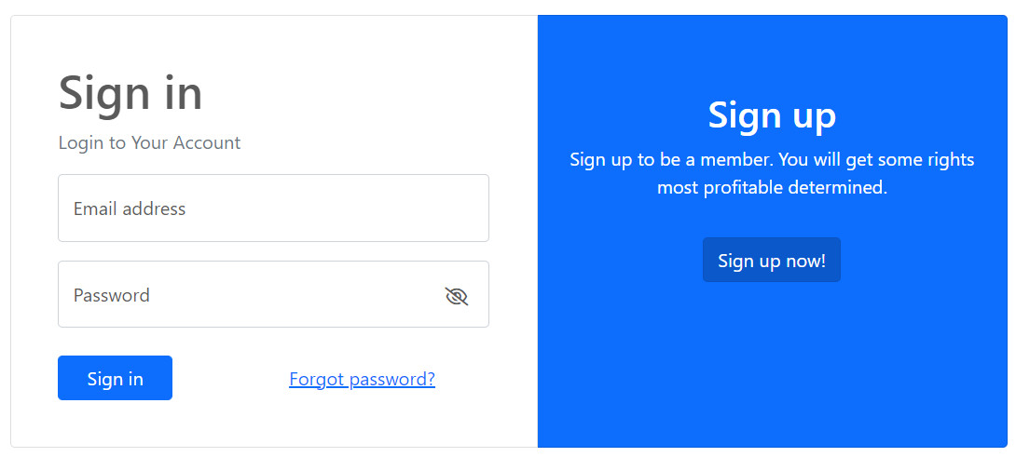

1. **Sign up**

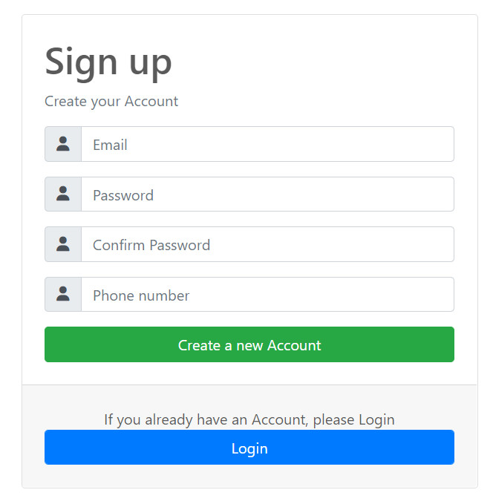

1. **Visa requirement**

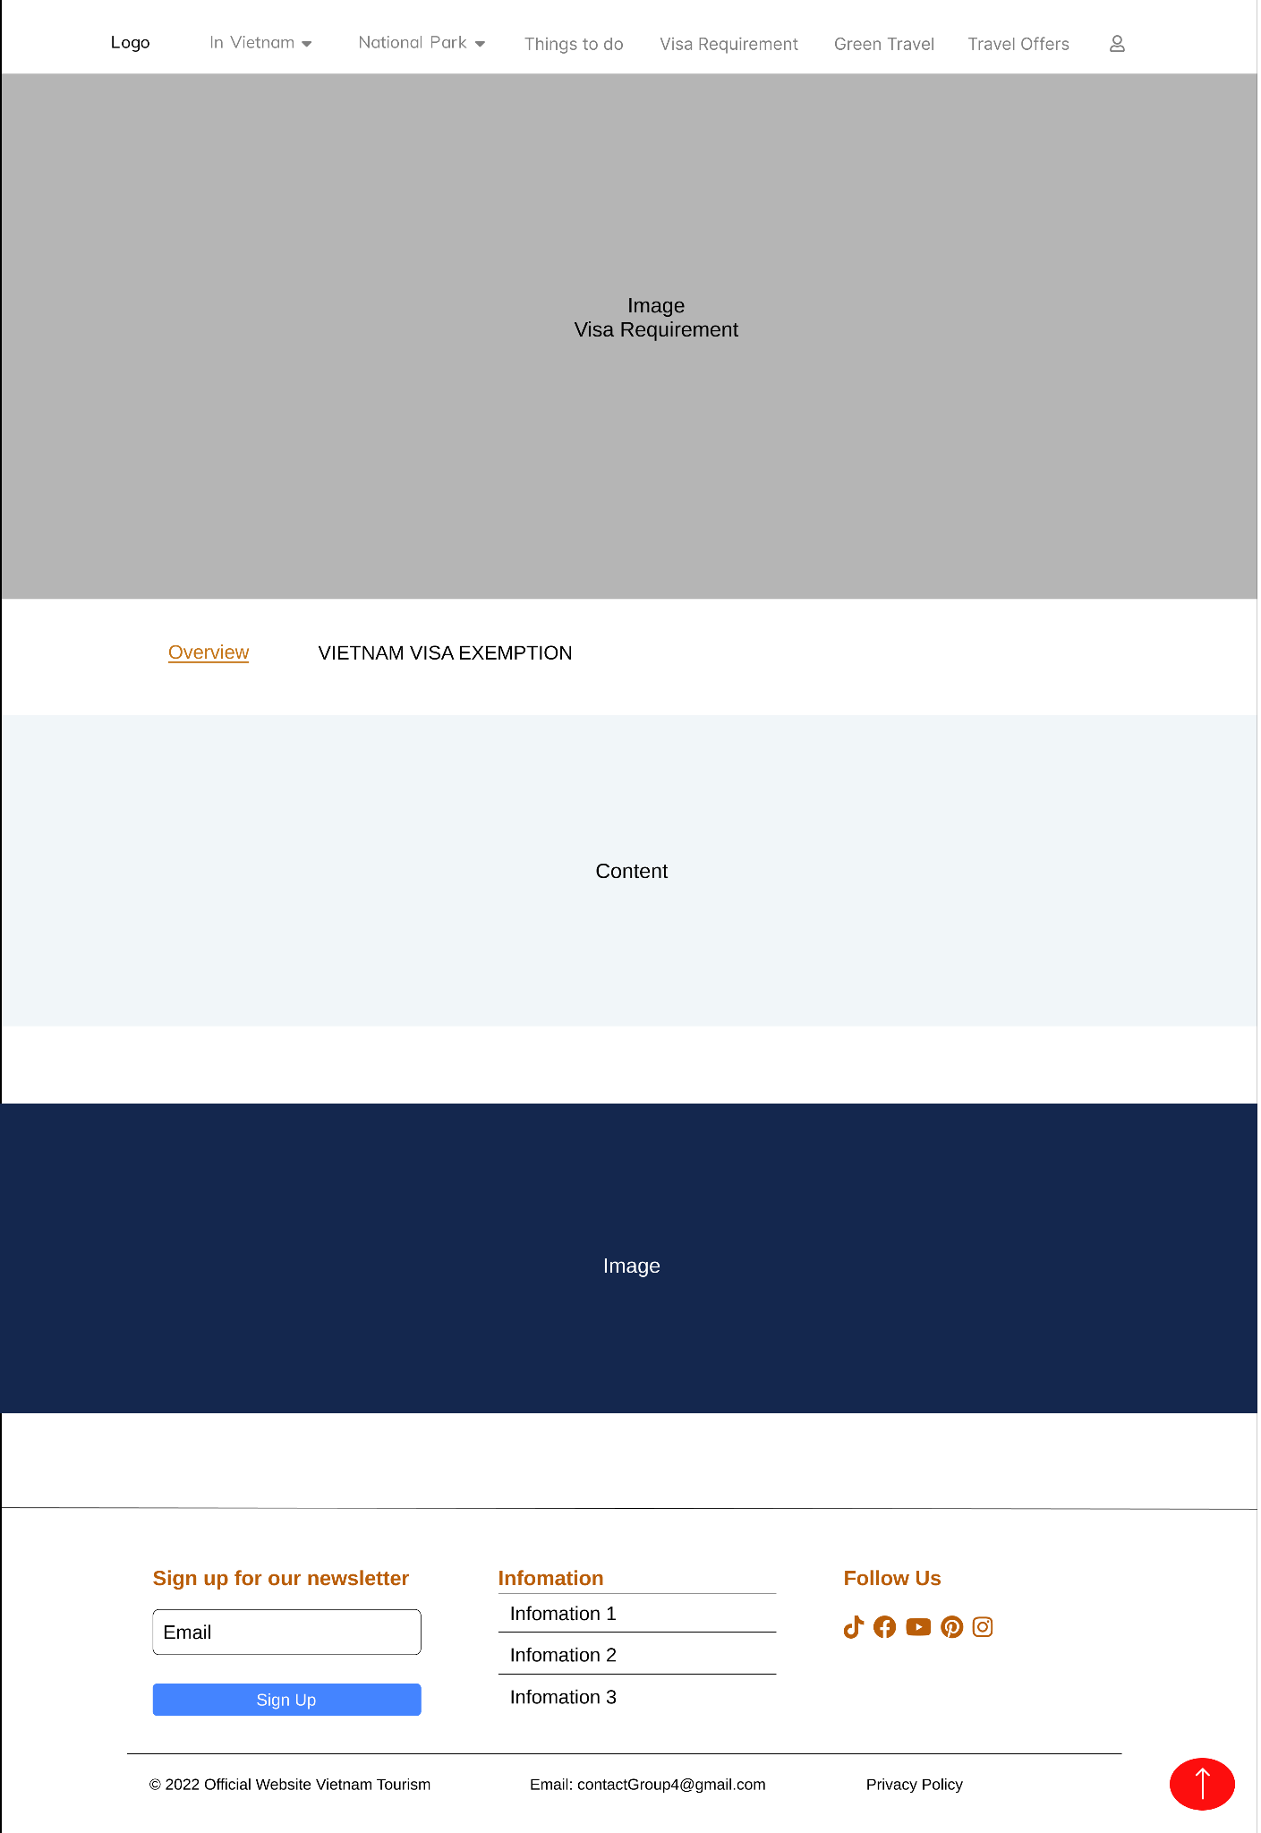

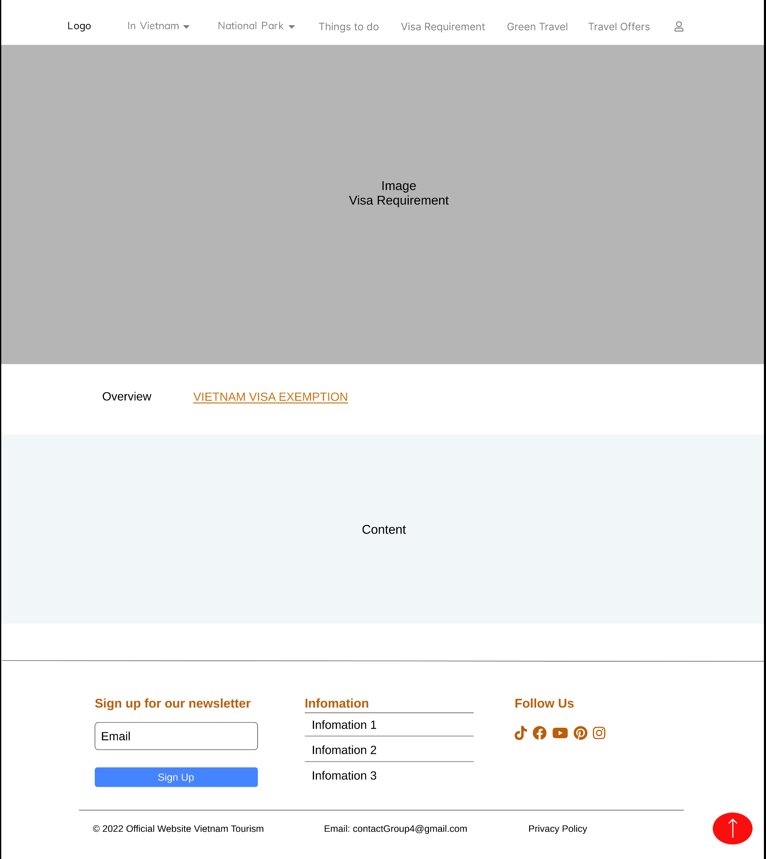

1. **Footer**

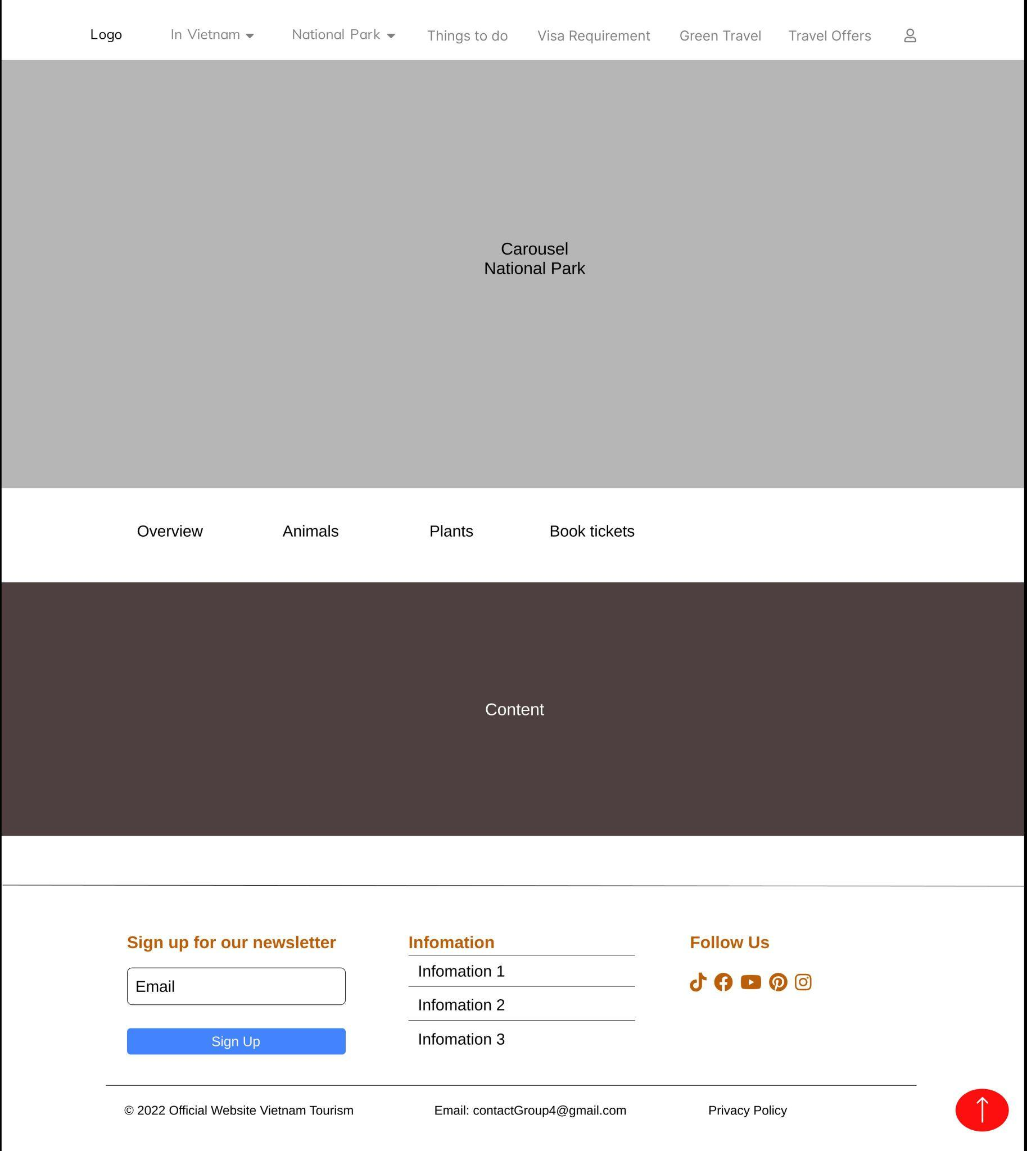

**Description:** When clicking on the “National Park” tag on the navigation site, the user is directed to this page. This page shows detailed information of the National Park.

**REVIEW 2**

**WEBSITE USER INTERFACE**

1. **Home Page**

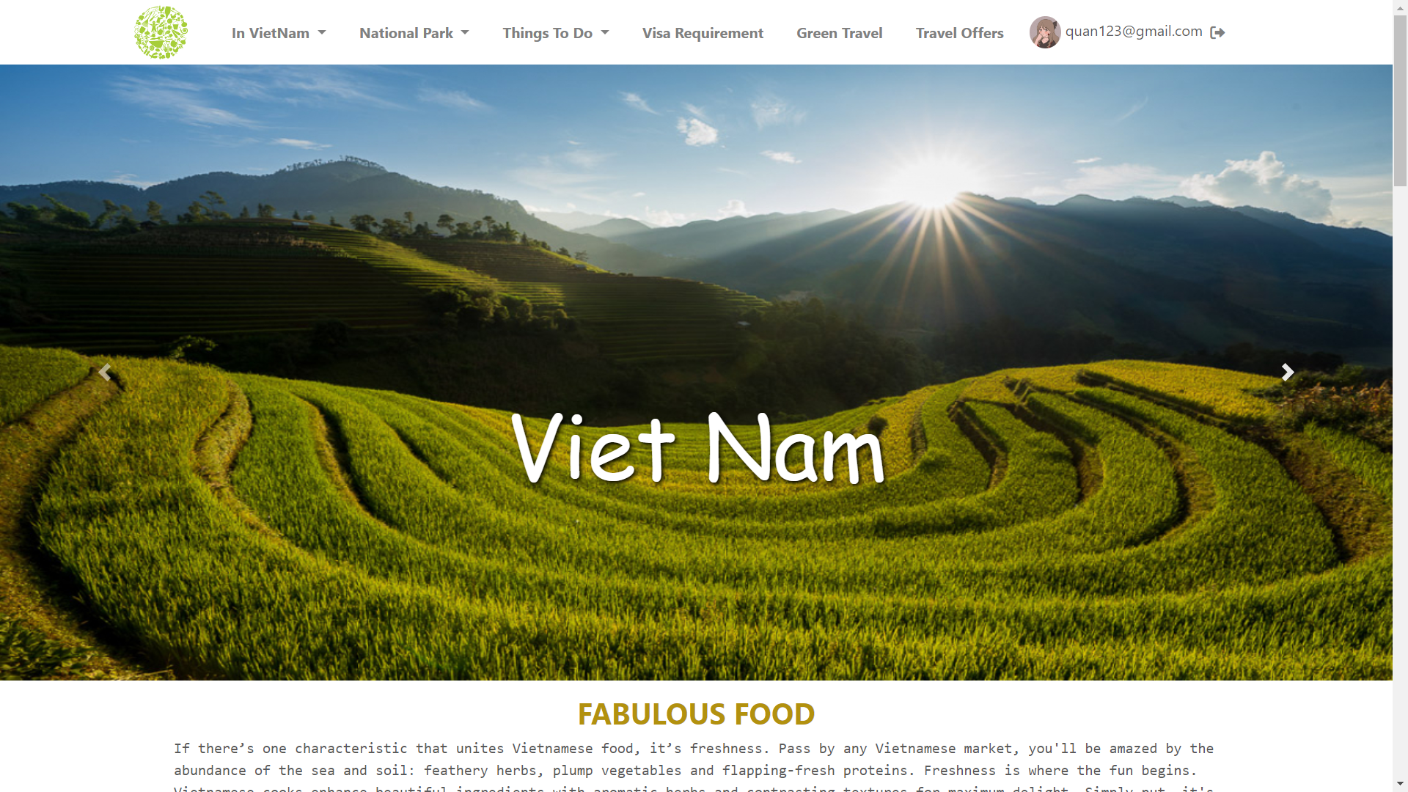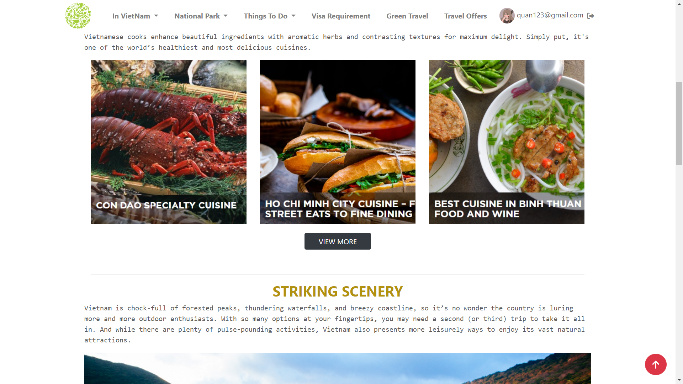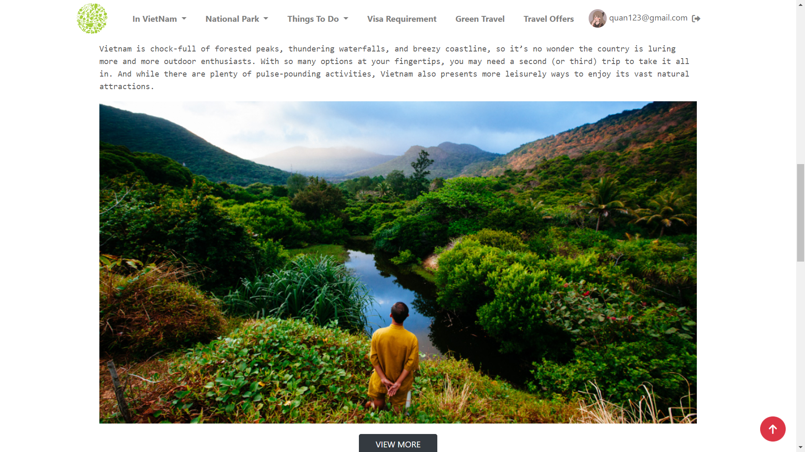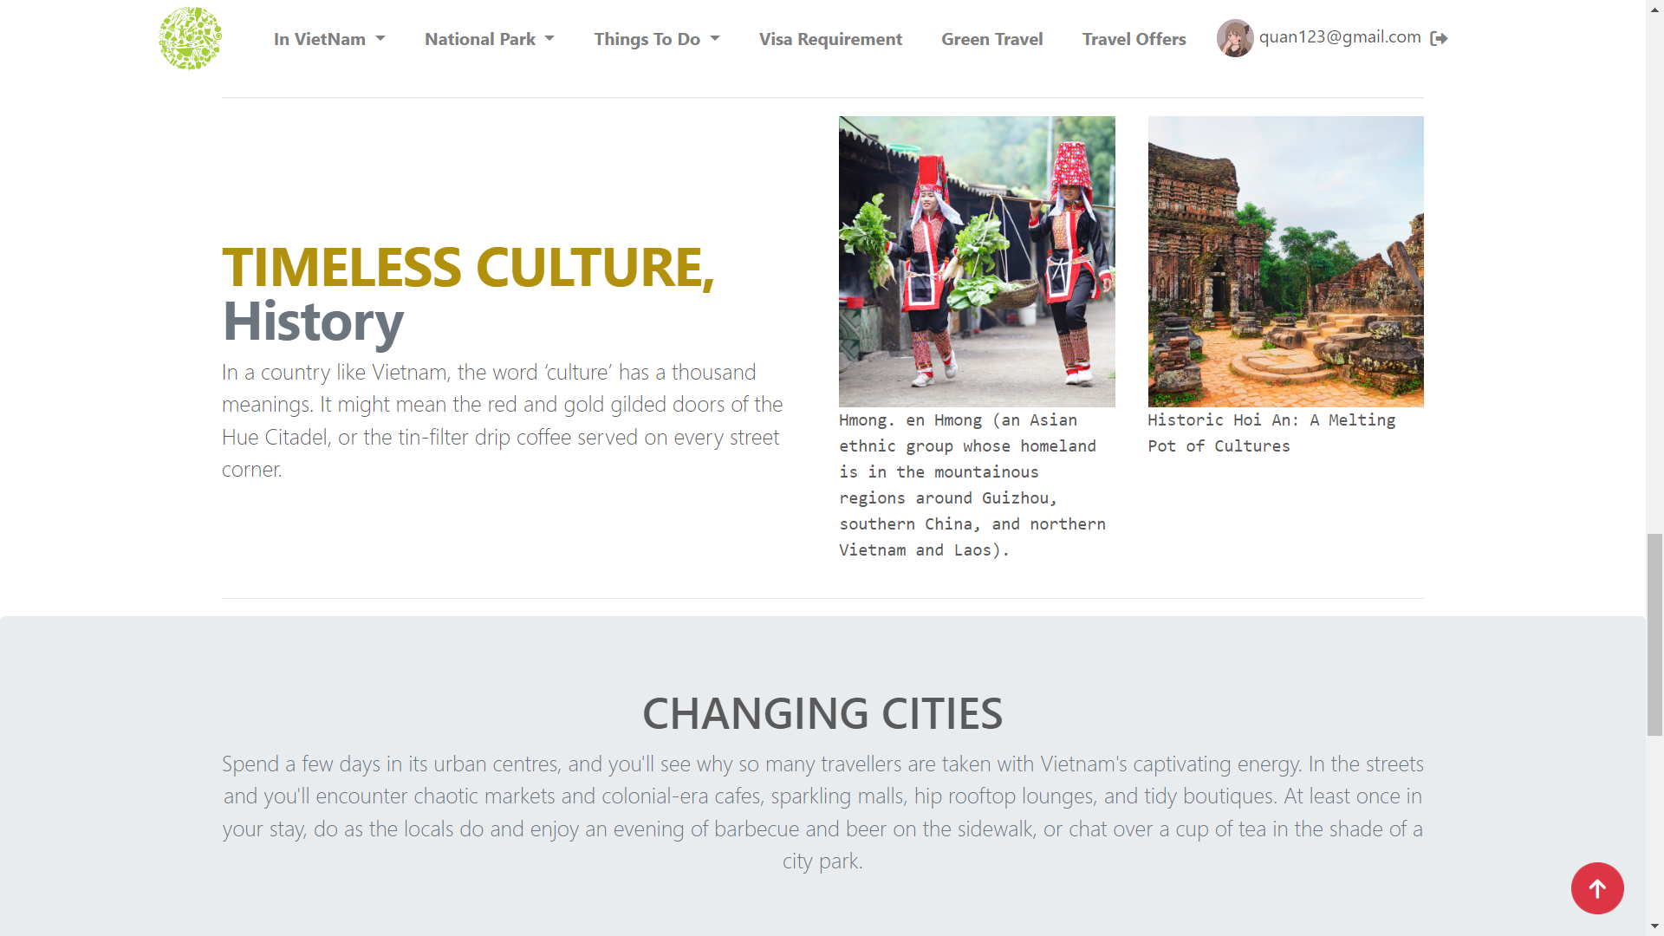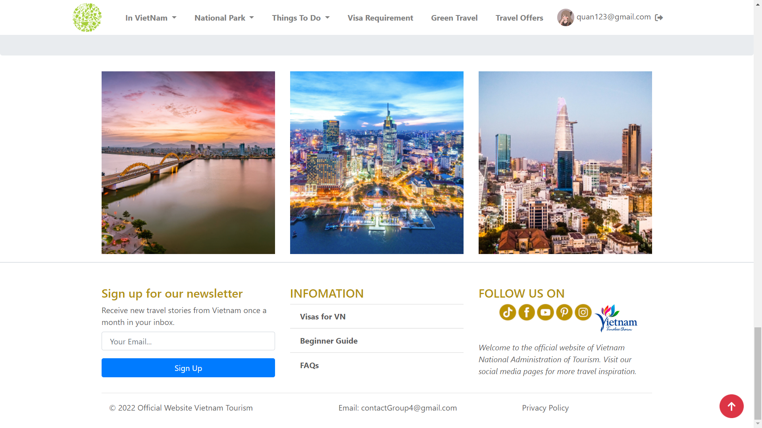

1. **NATION PARK**
2. **Overview**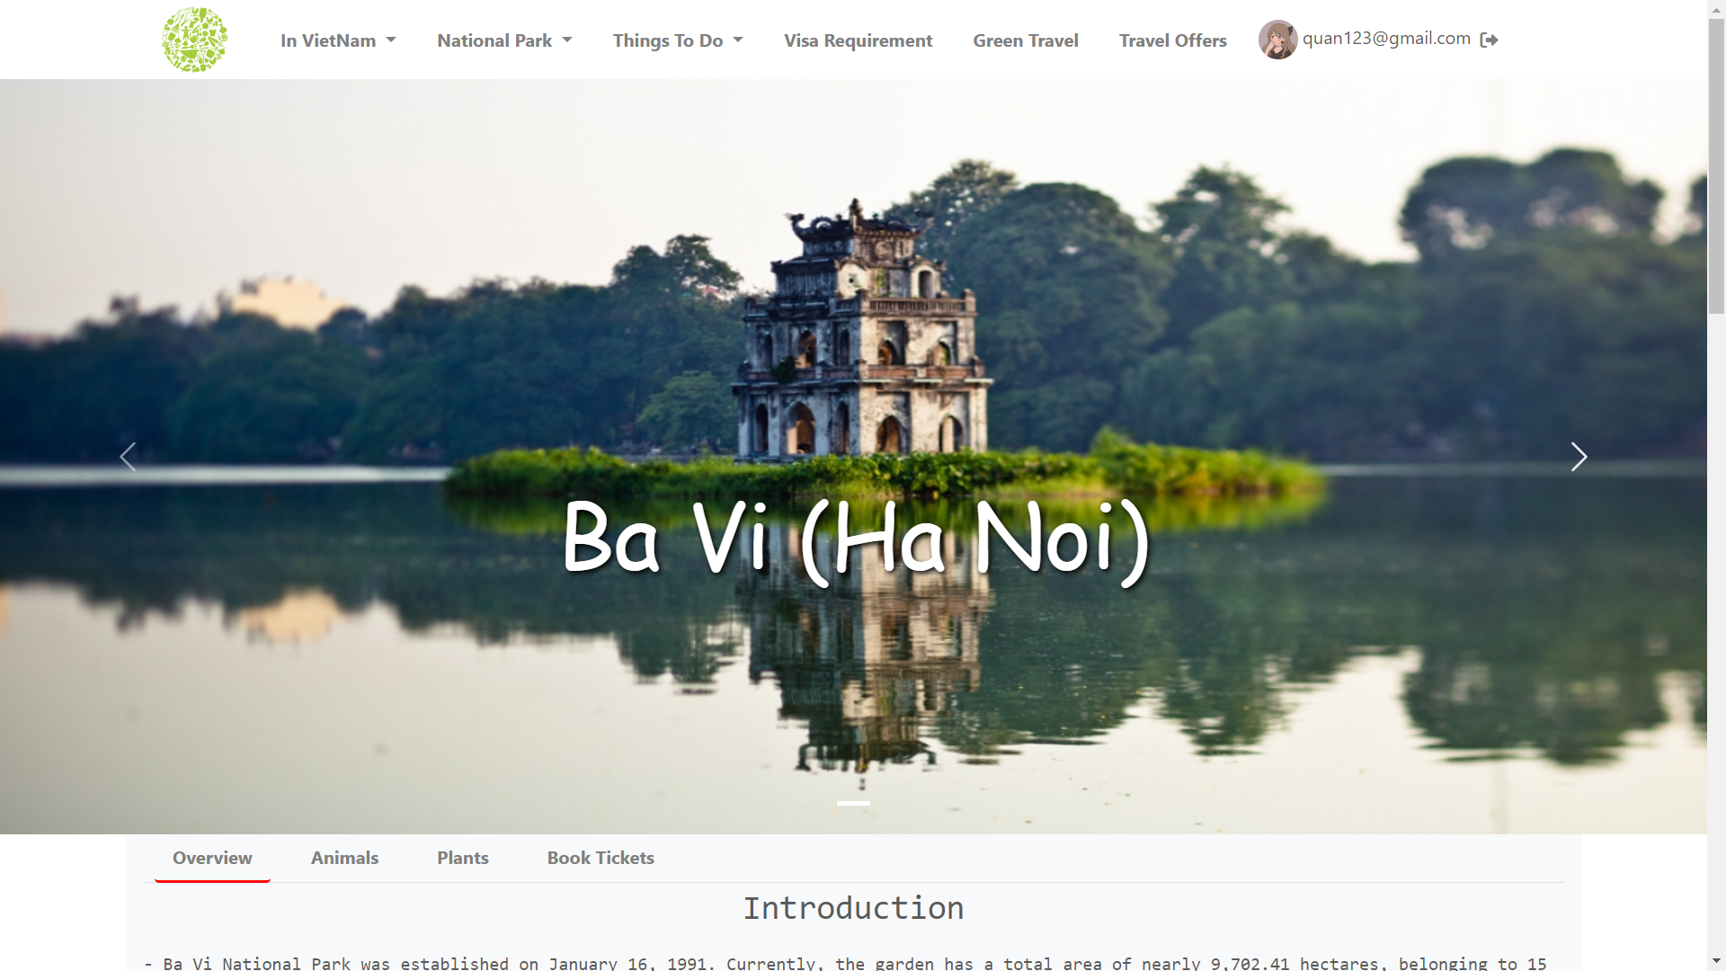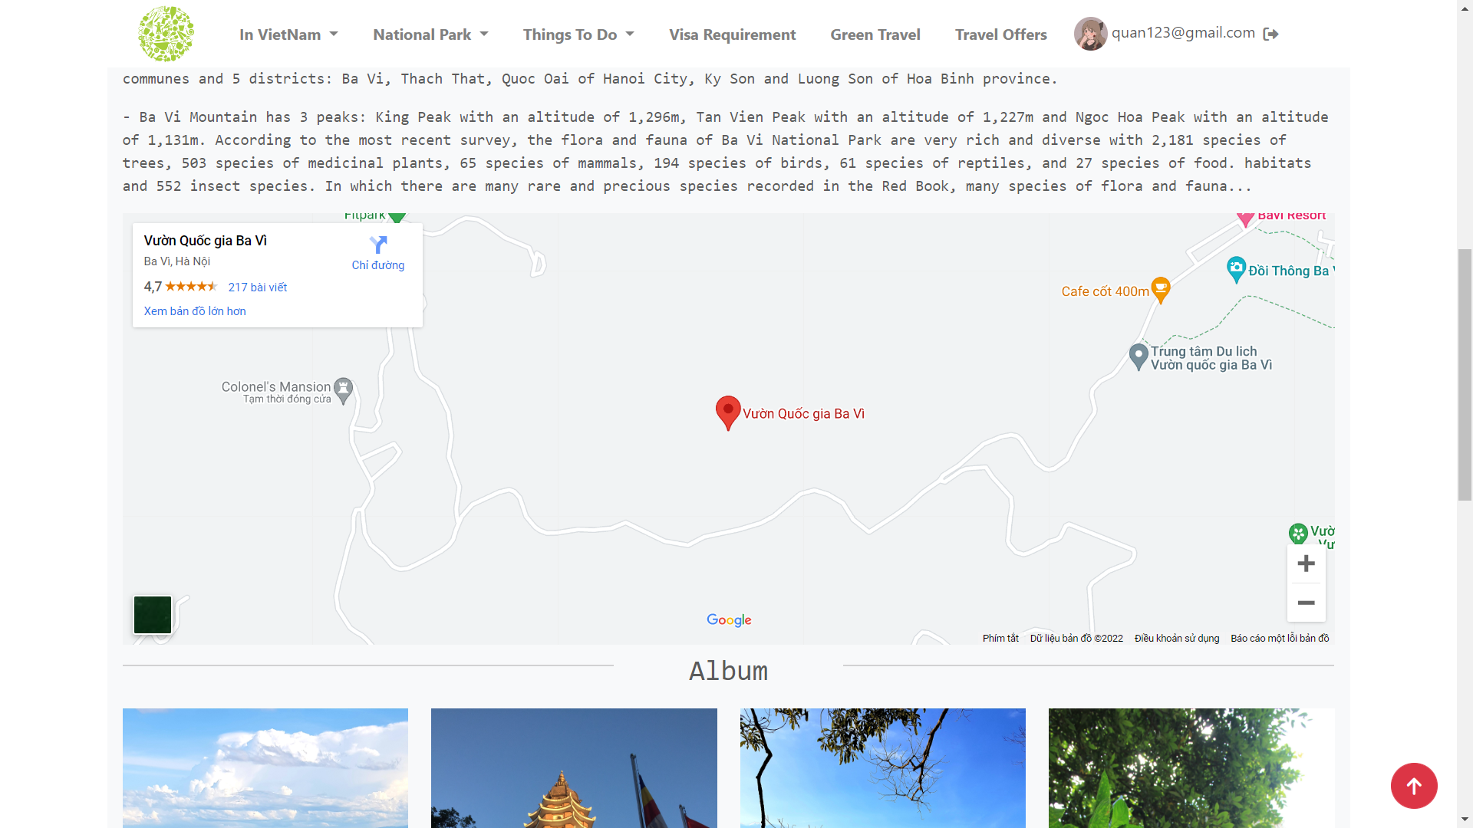

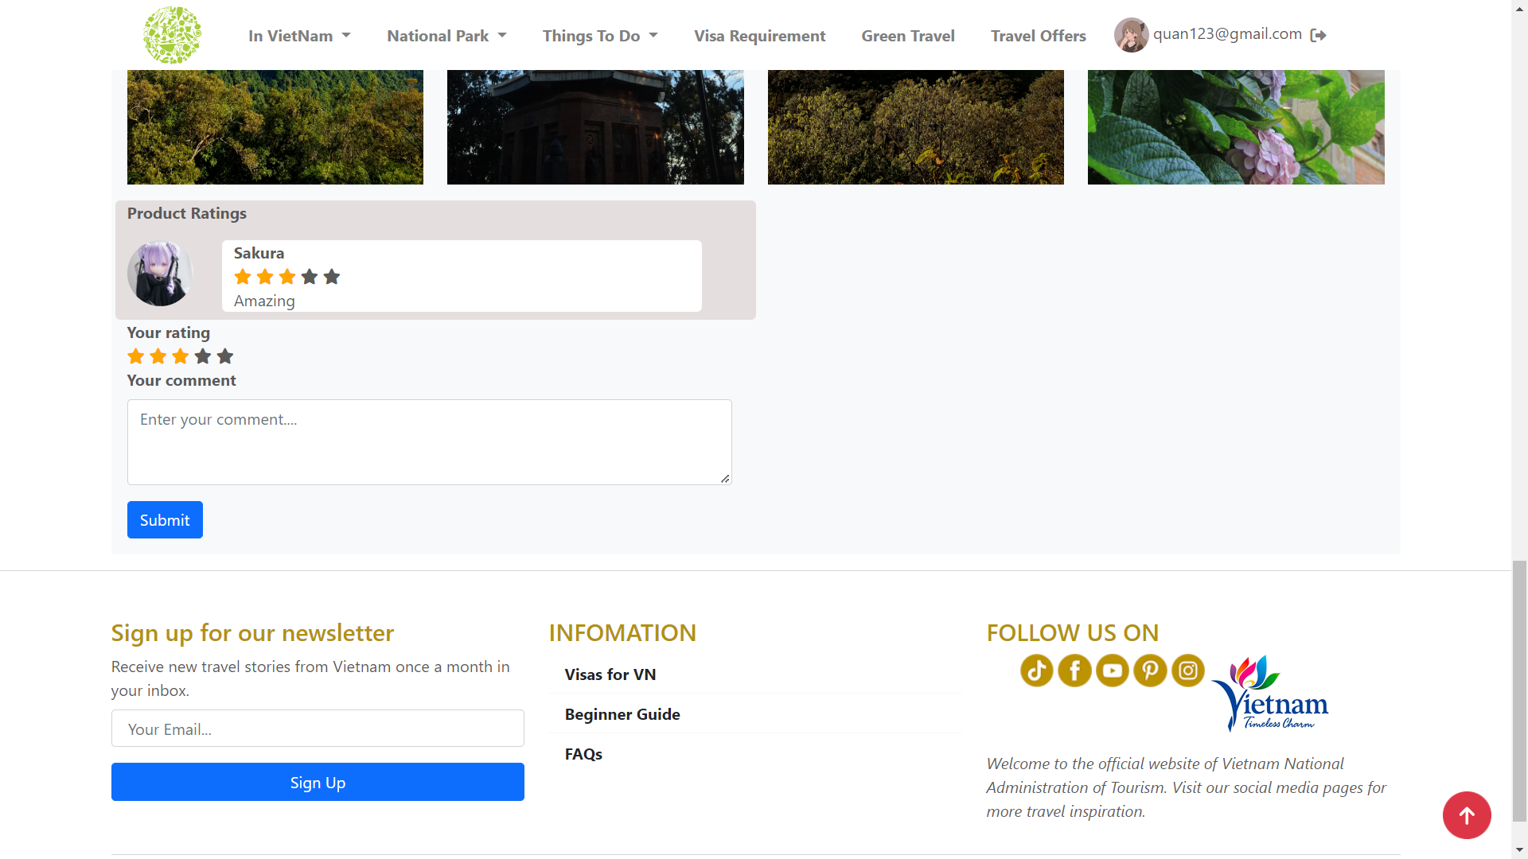

1. **Animals**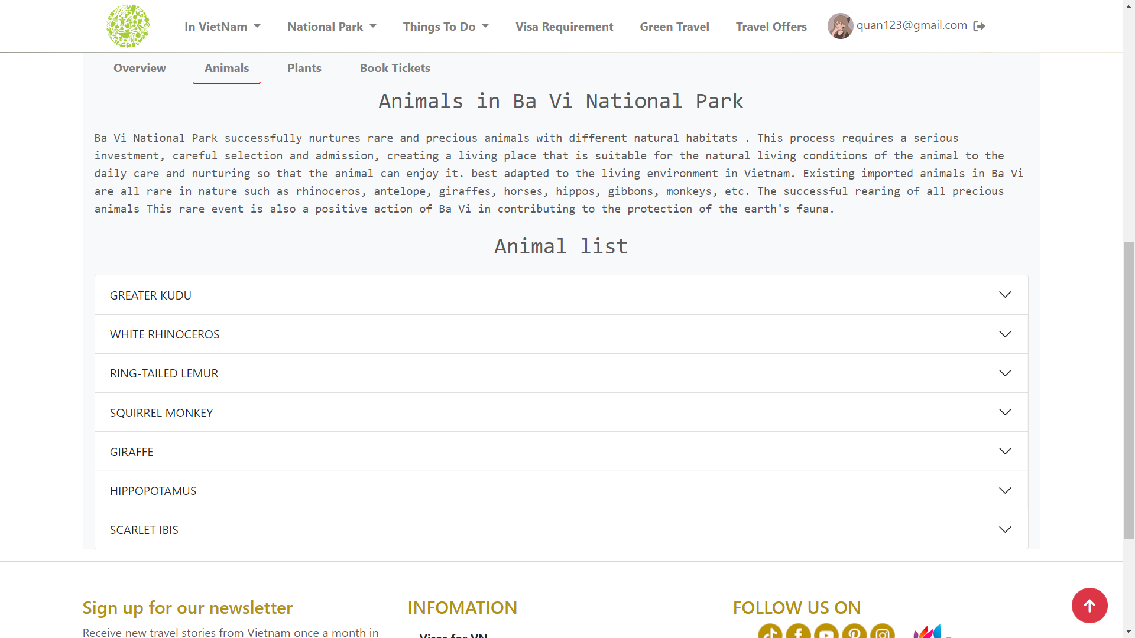

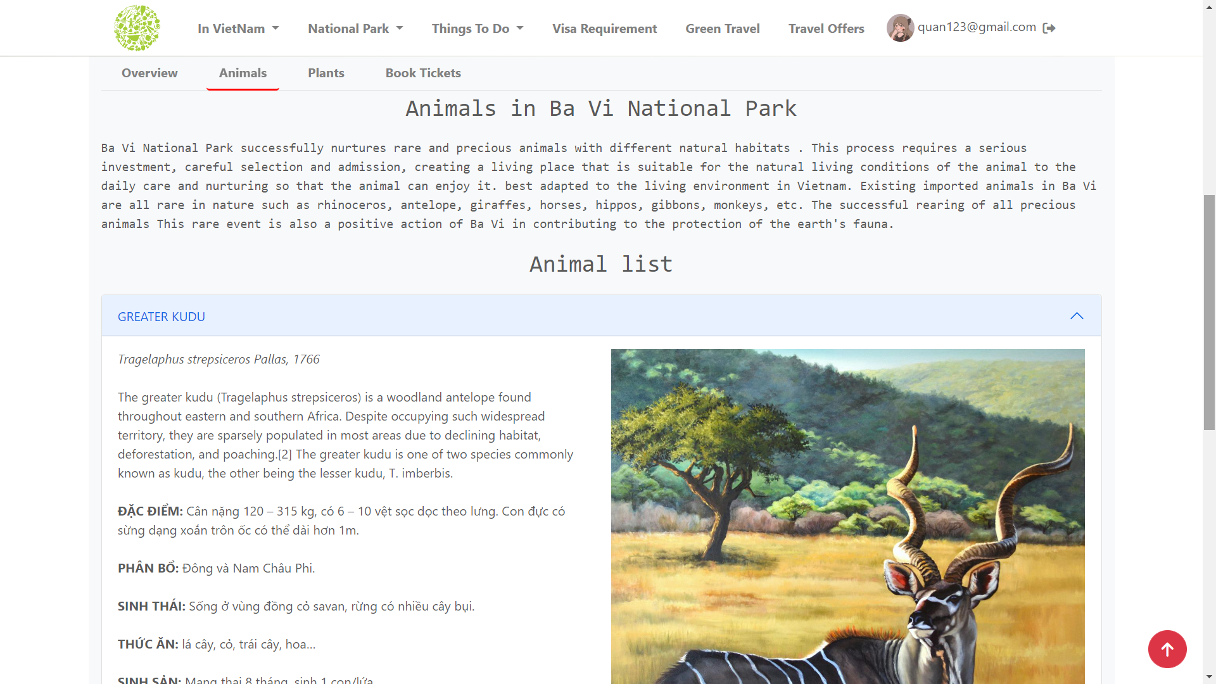

1. **Plans**

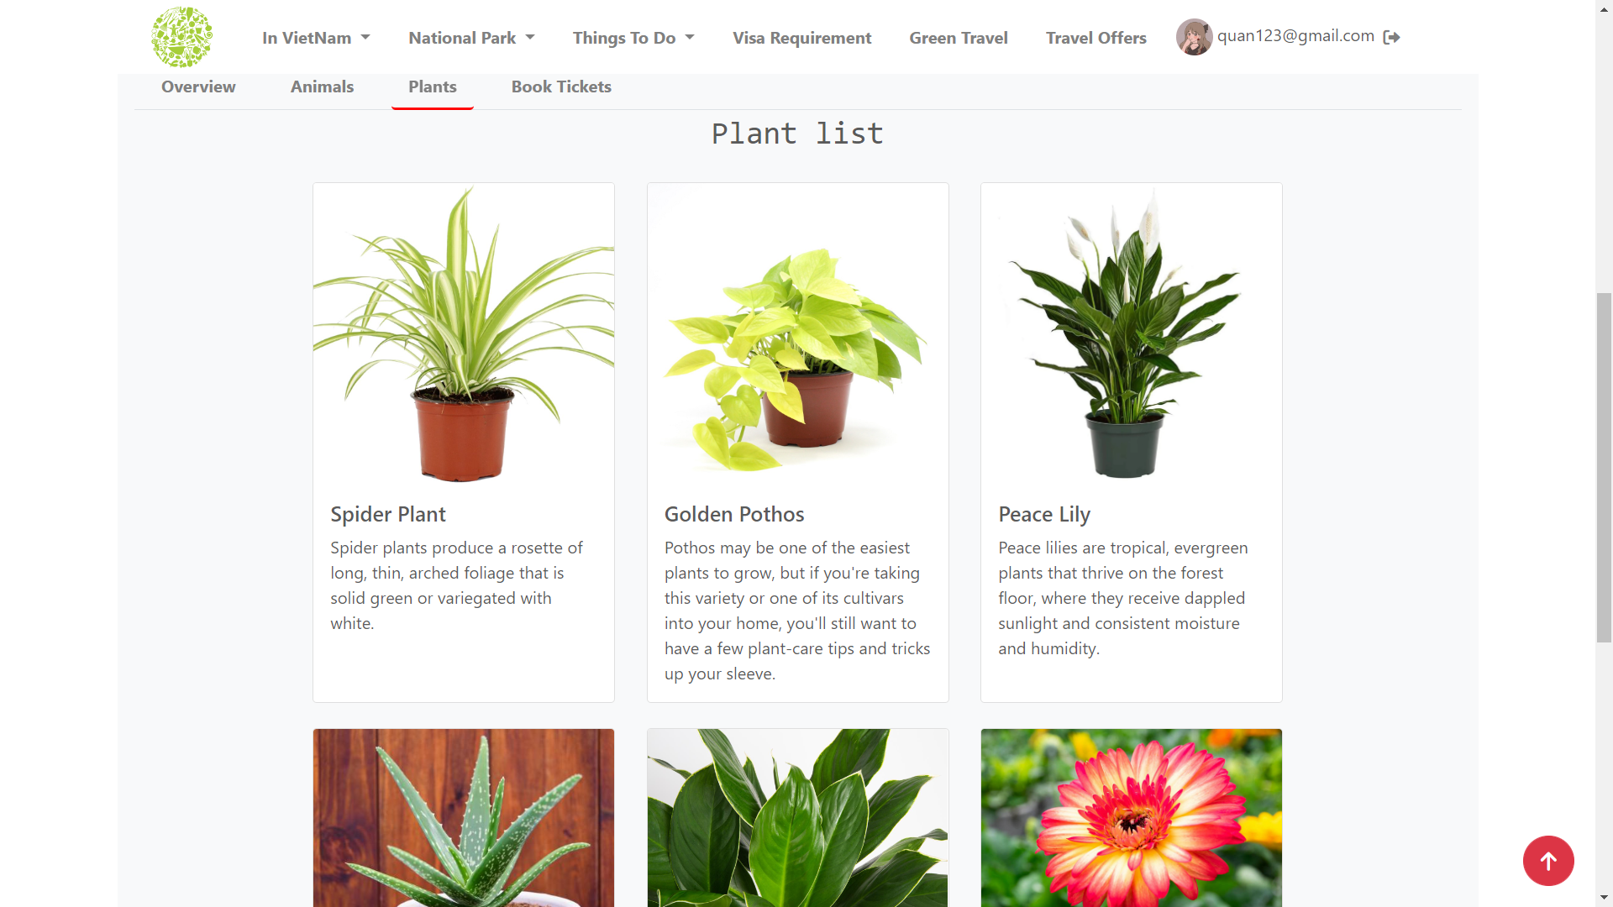

1. **Book Tickets**

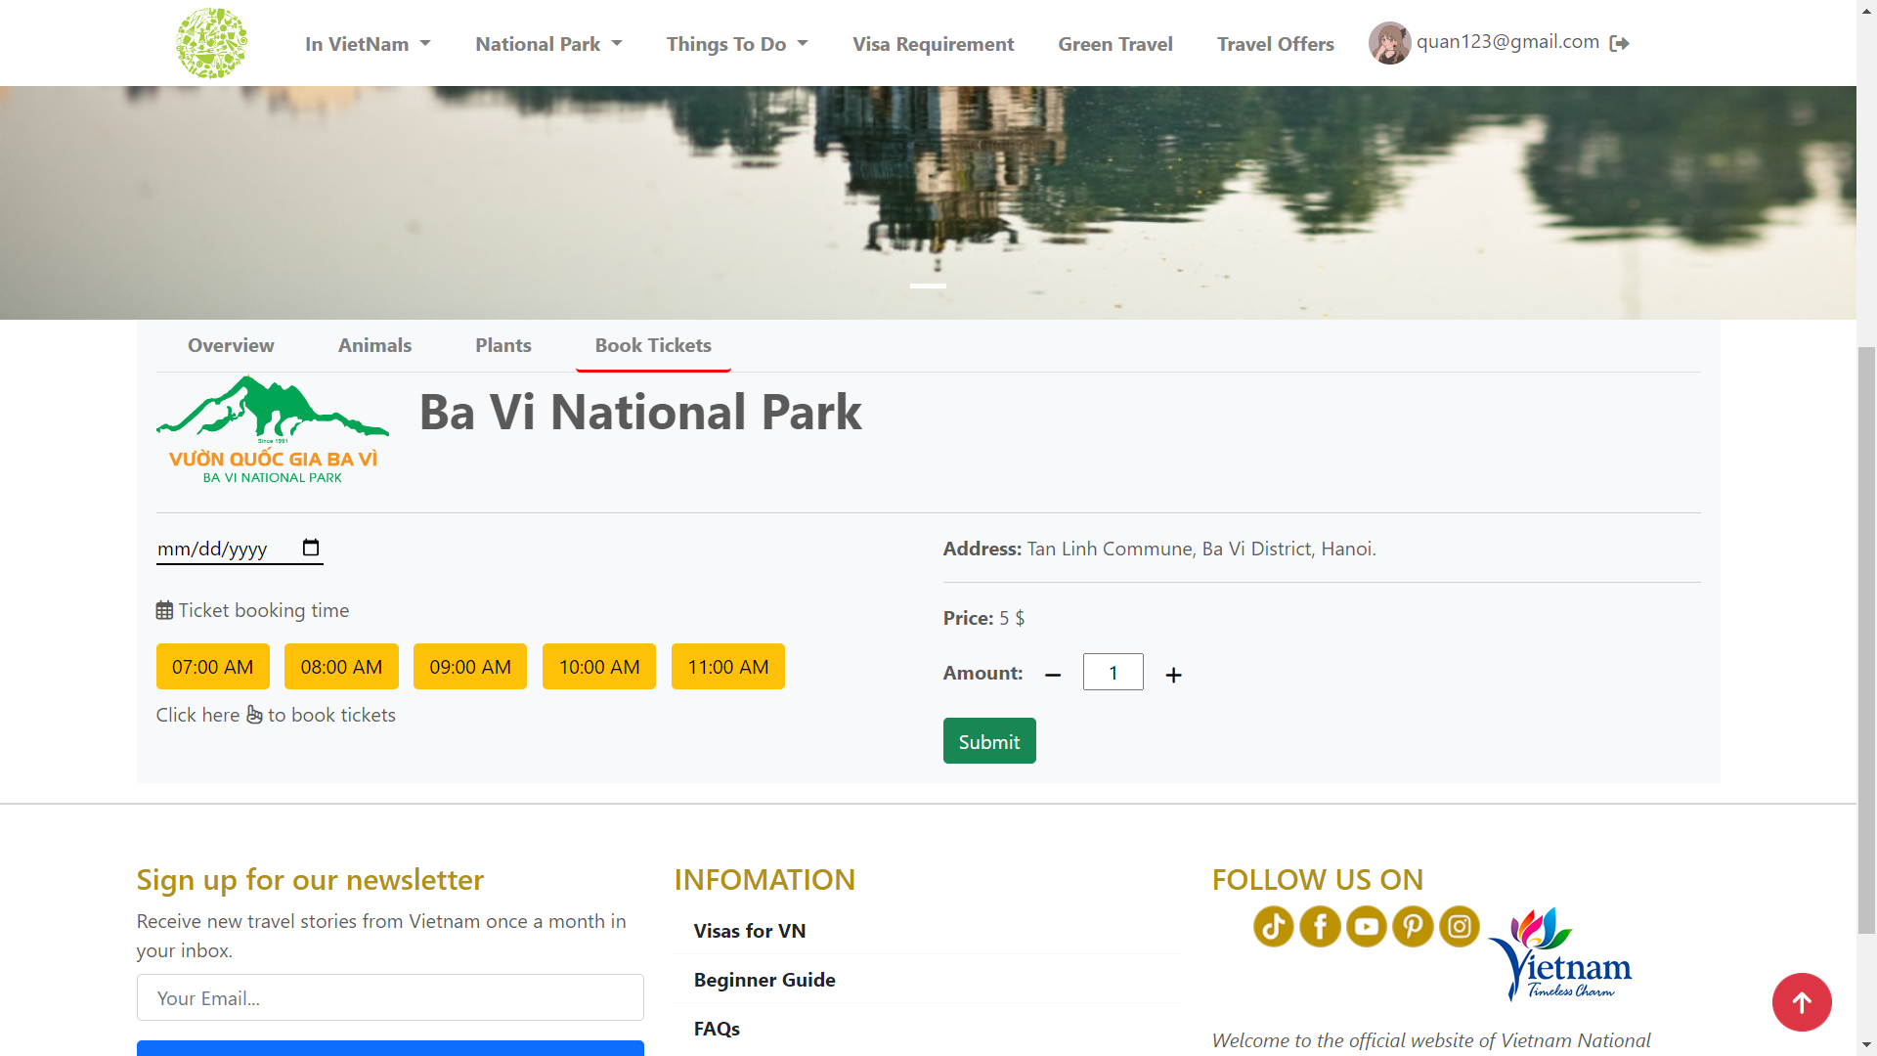

**III. Things To Do**

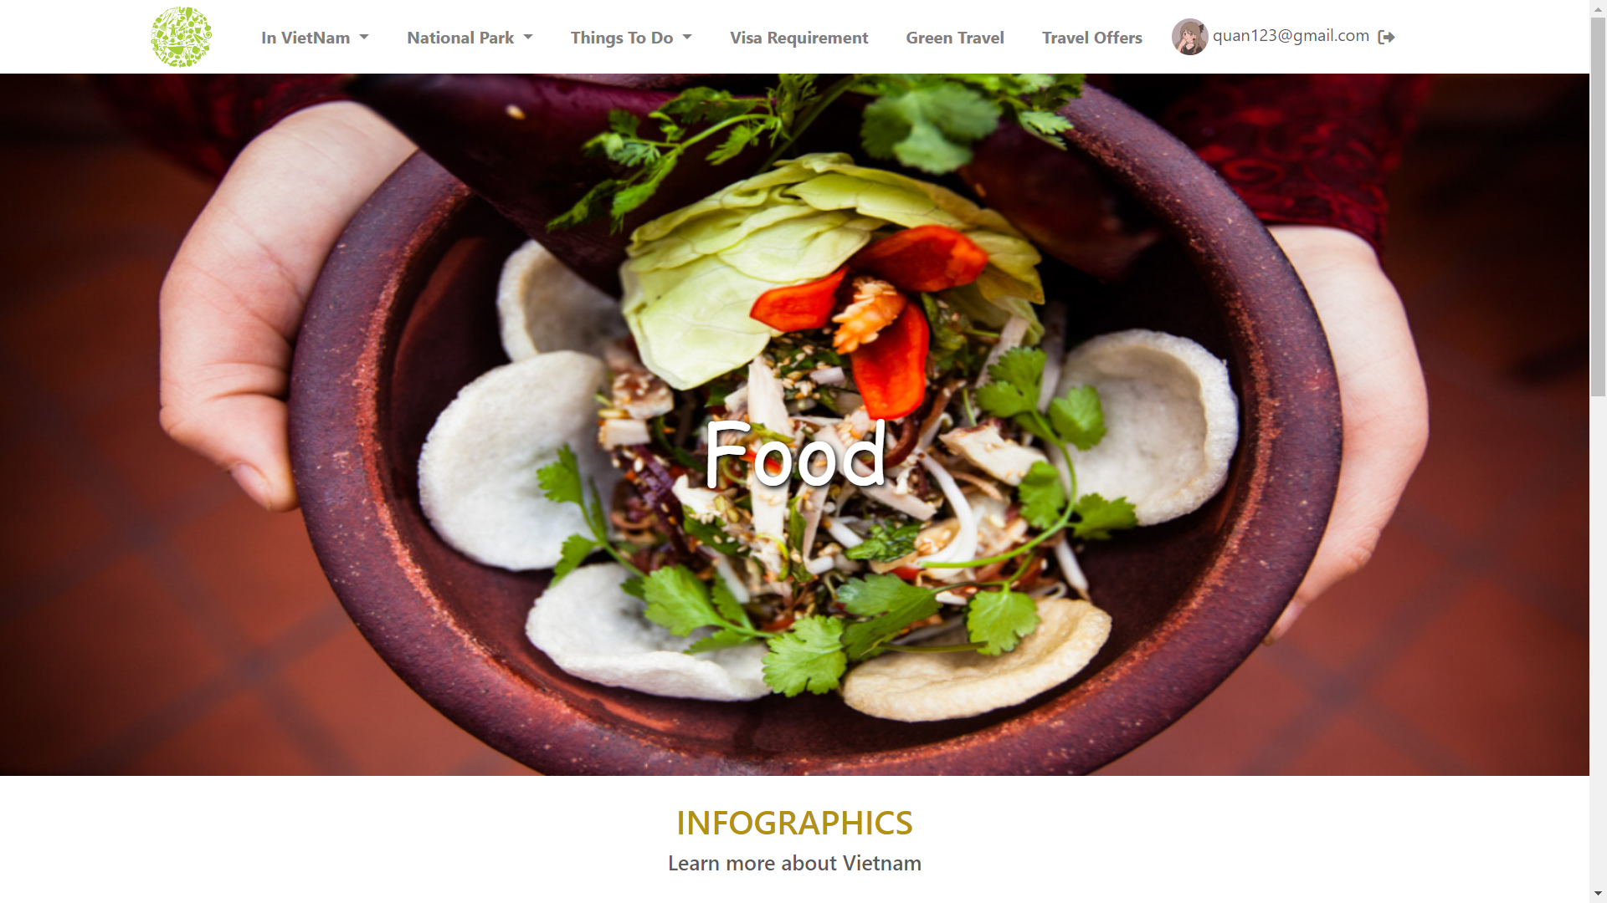

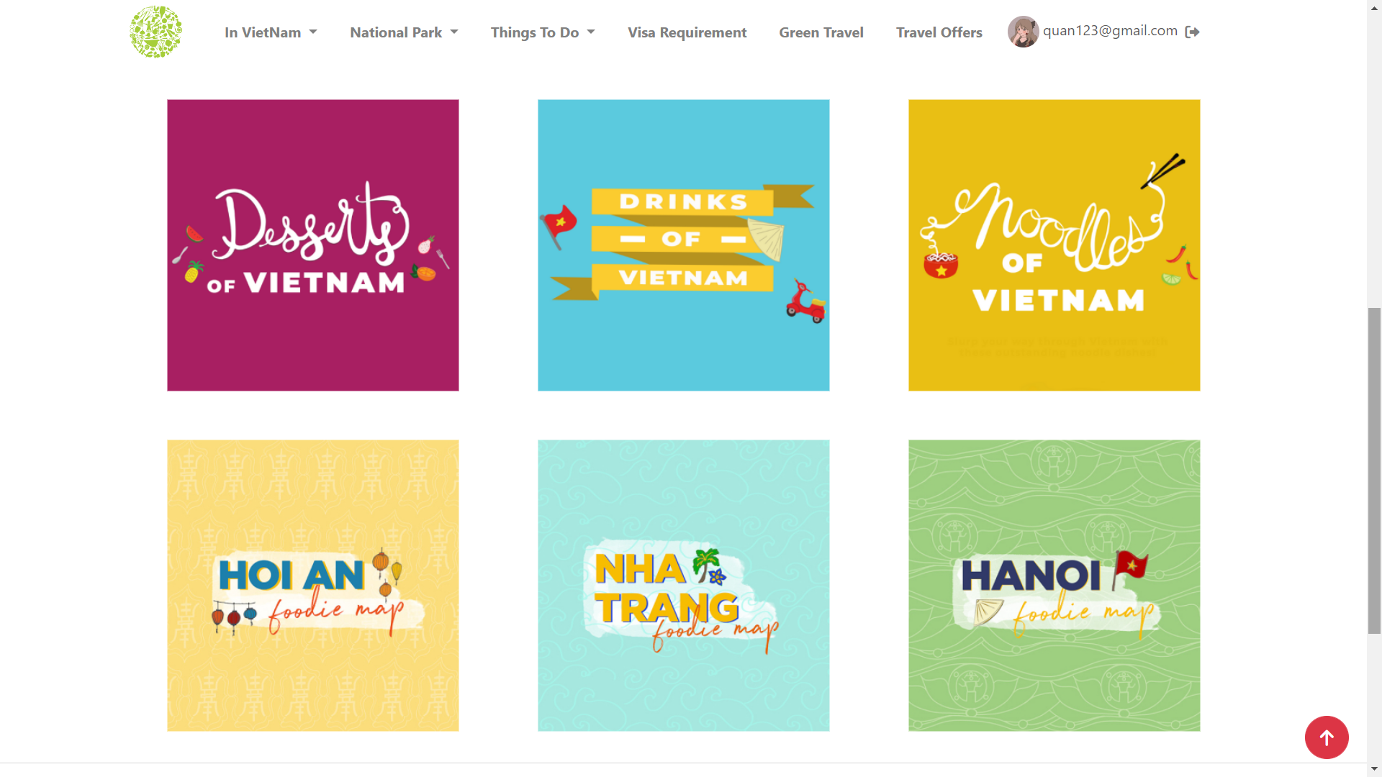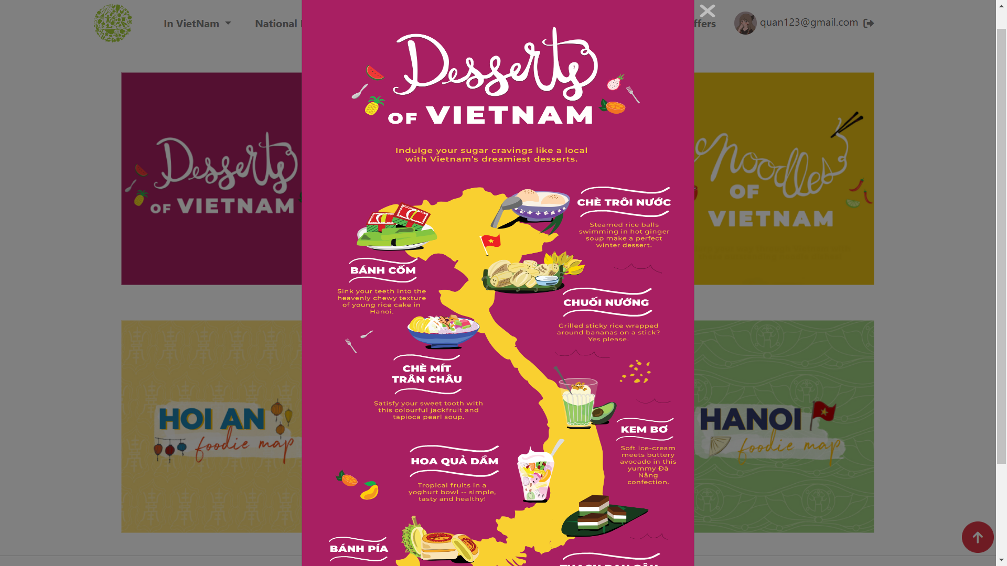

**IV. VISA REQUIREMENT  
 1. Overview**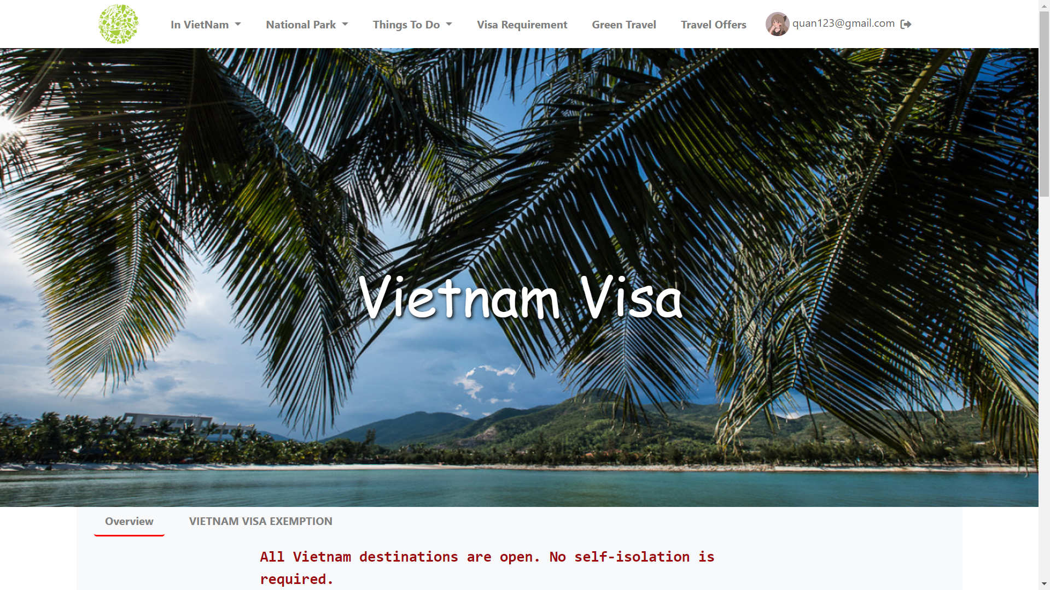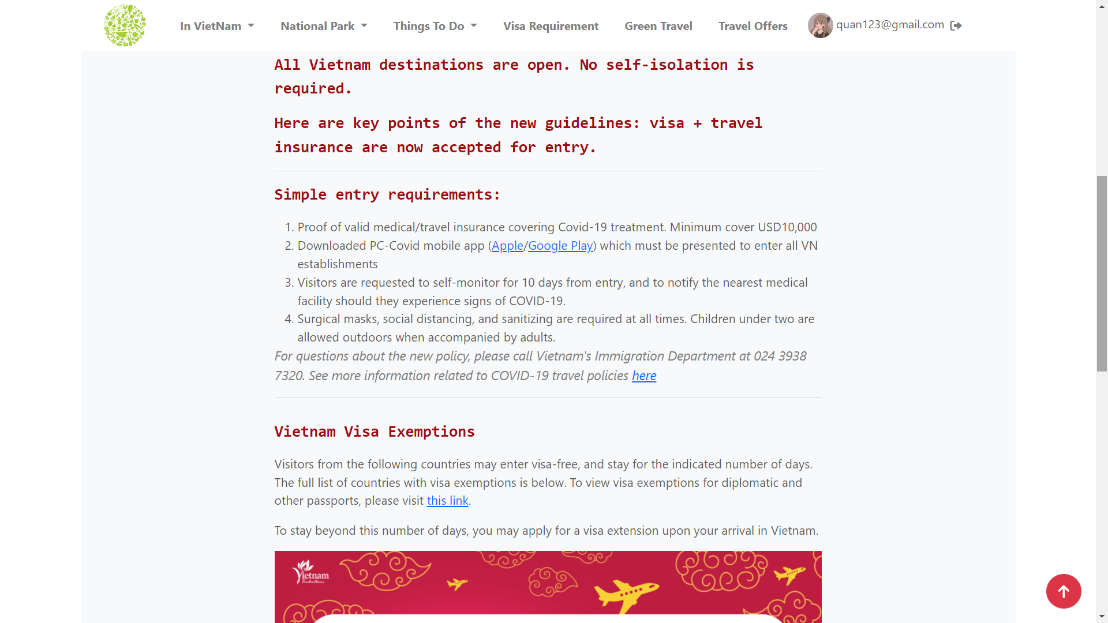

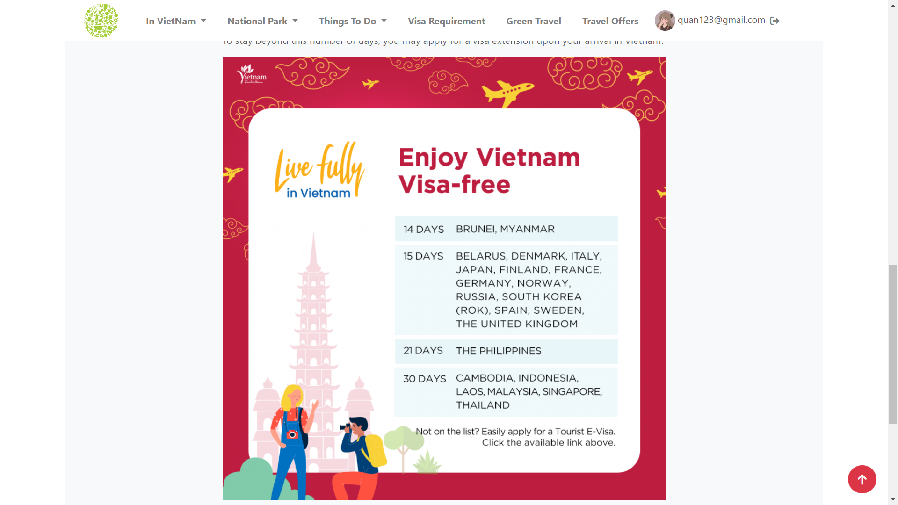

**2. VIETNAM VISA EXEMPTION**

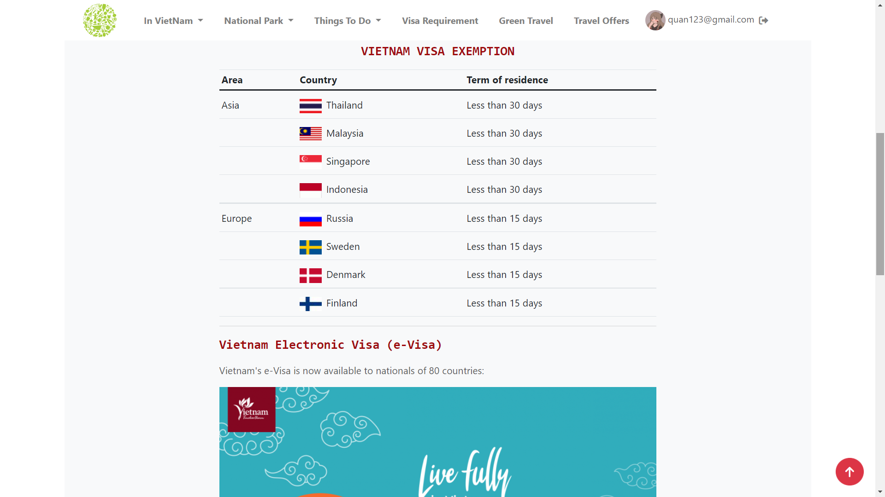

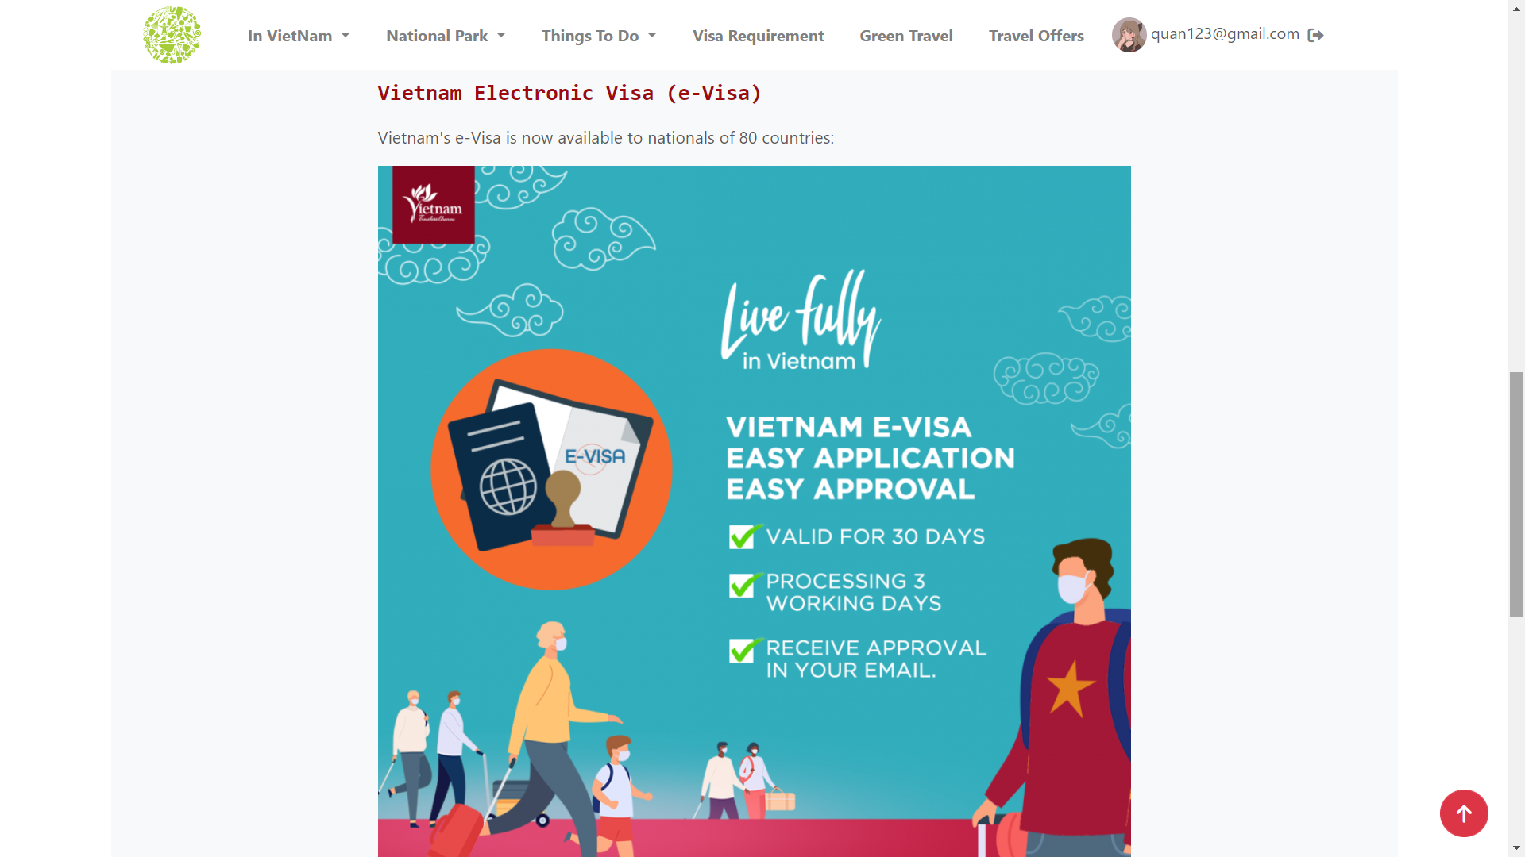

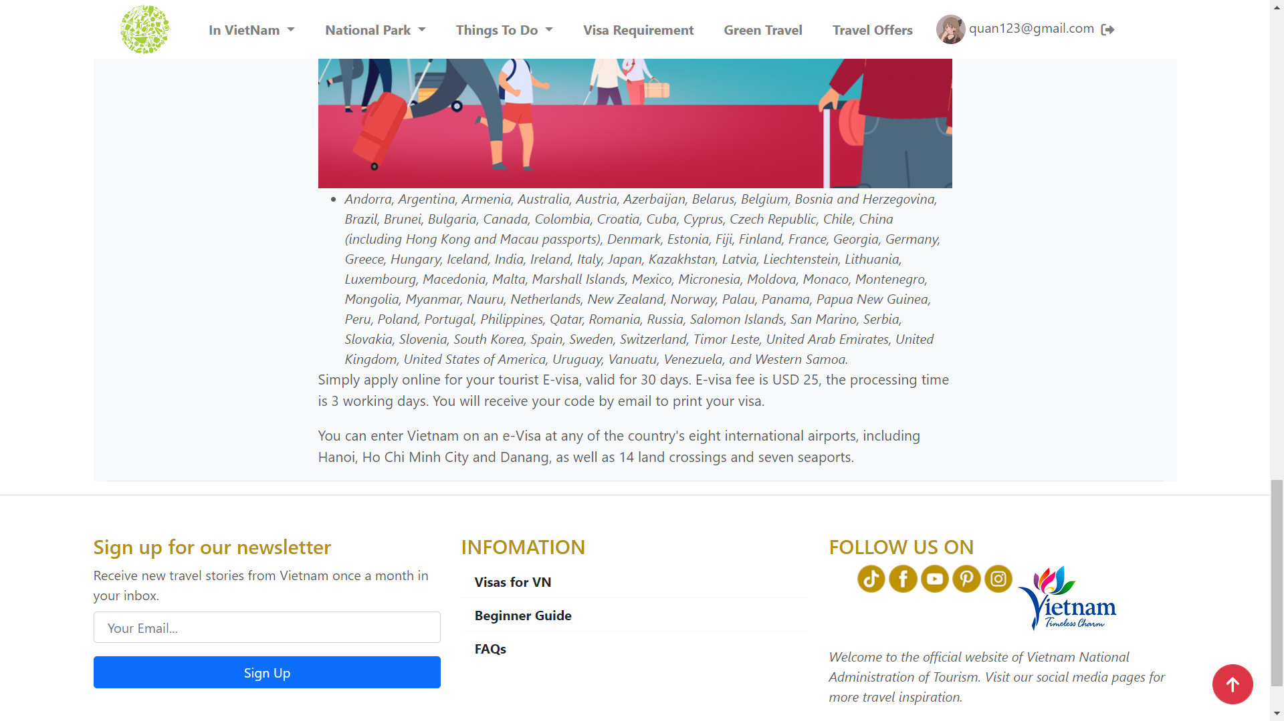

**V. GREEN TRAVEL**

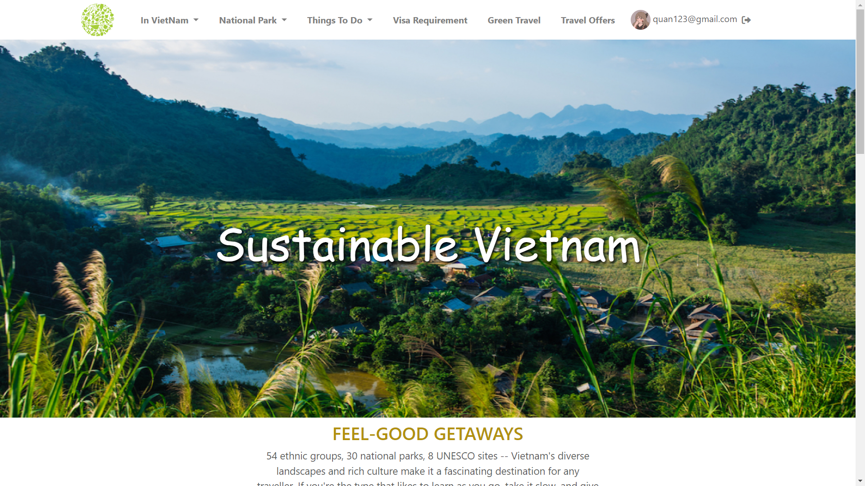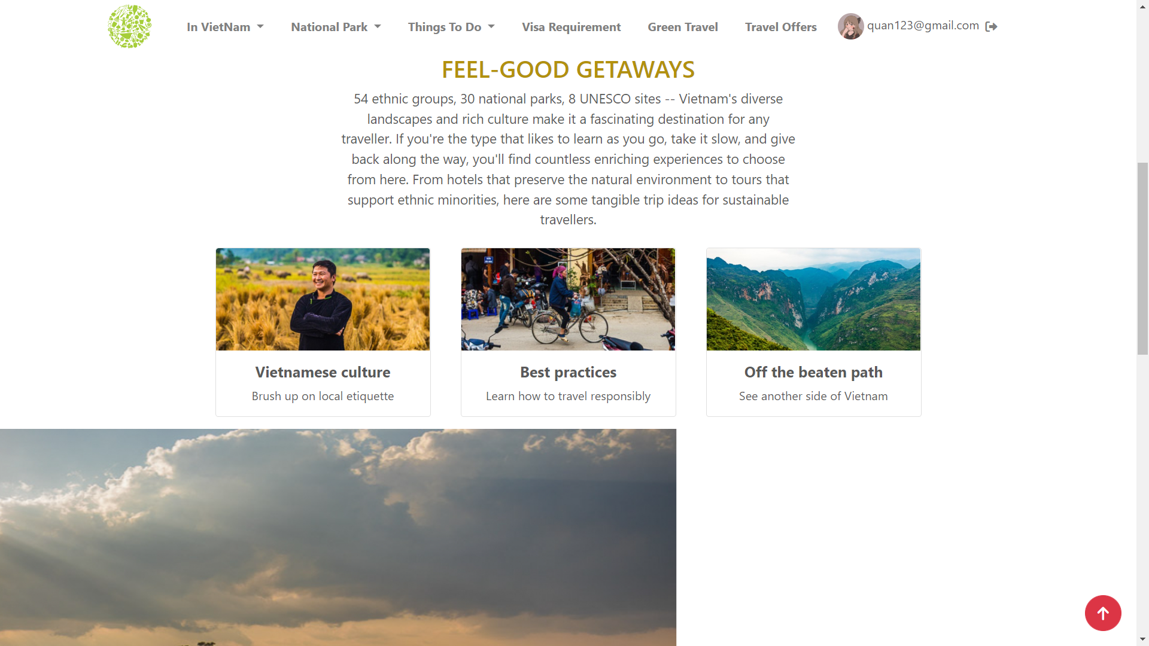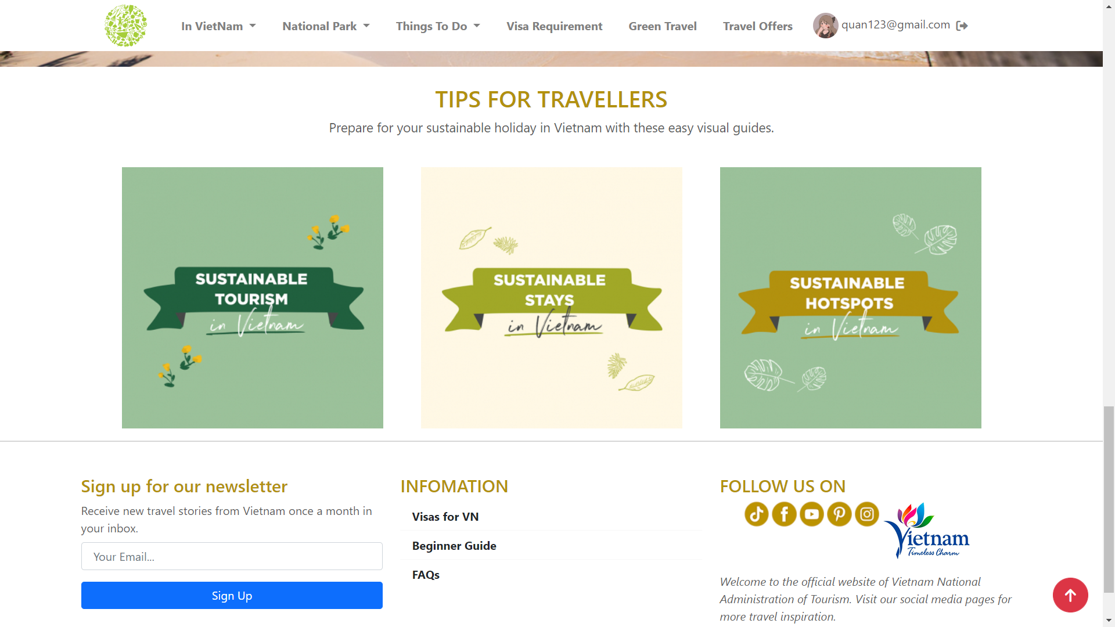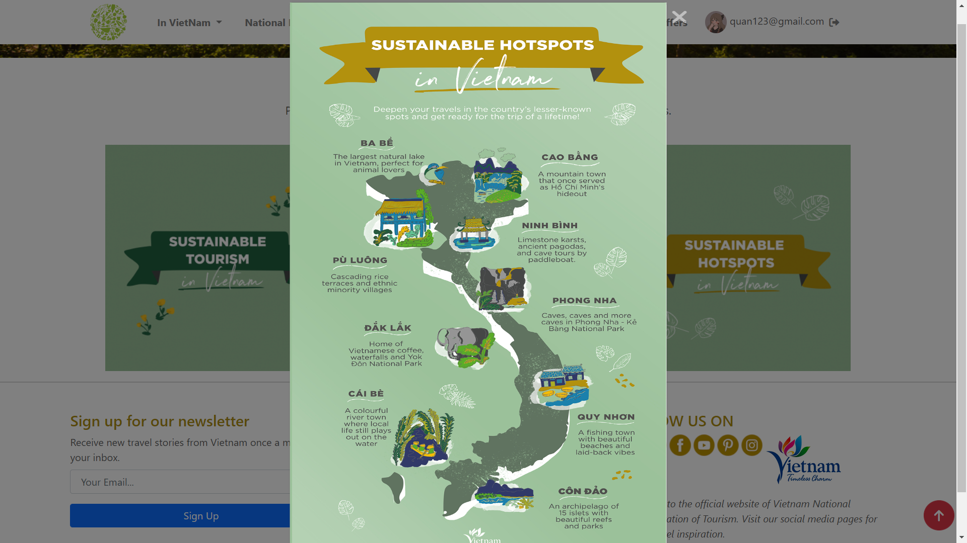

**VI. TRAVEL OFFER**

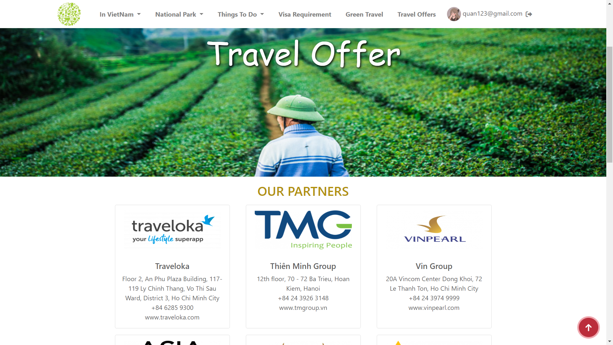

**VII. SIGN UP**

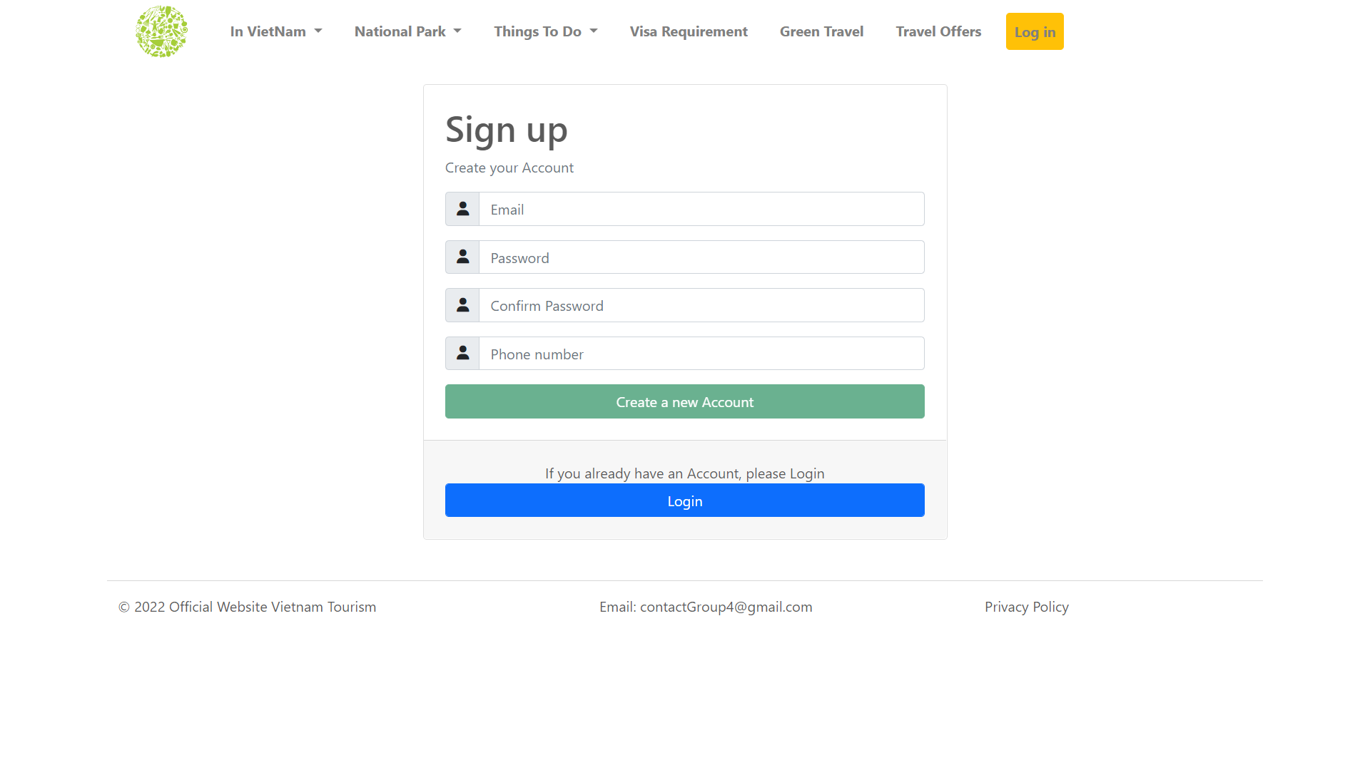

**VIII. SIGN IN**

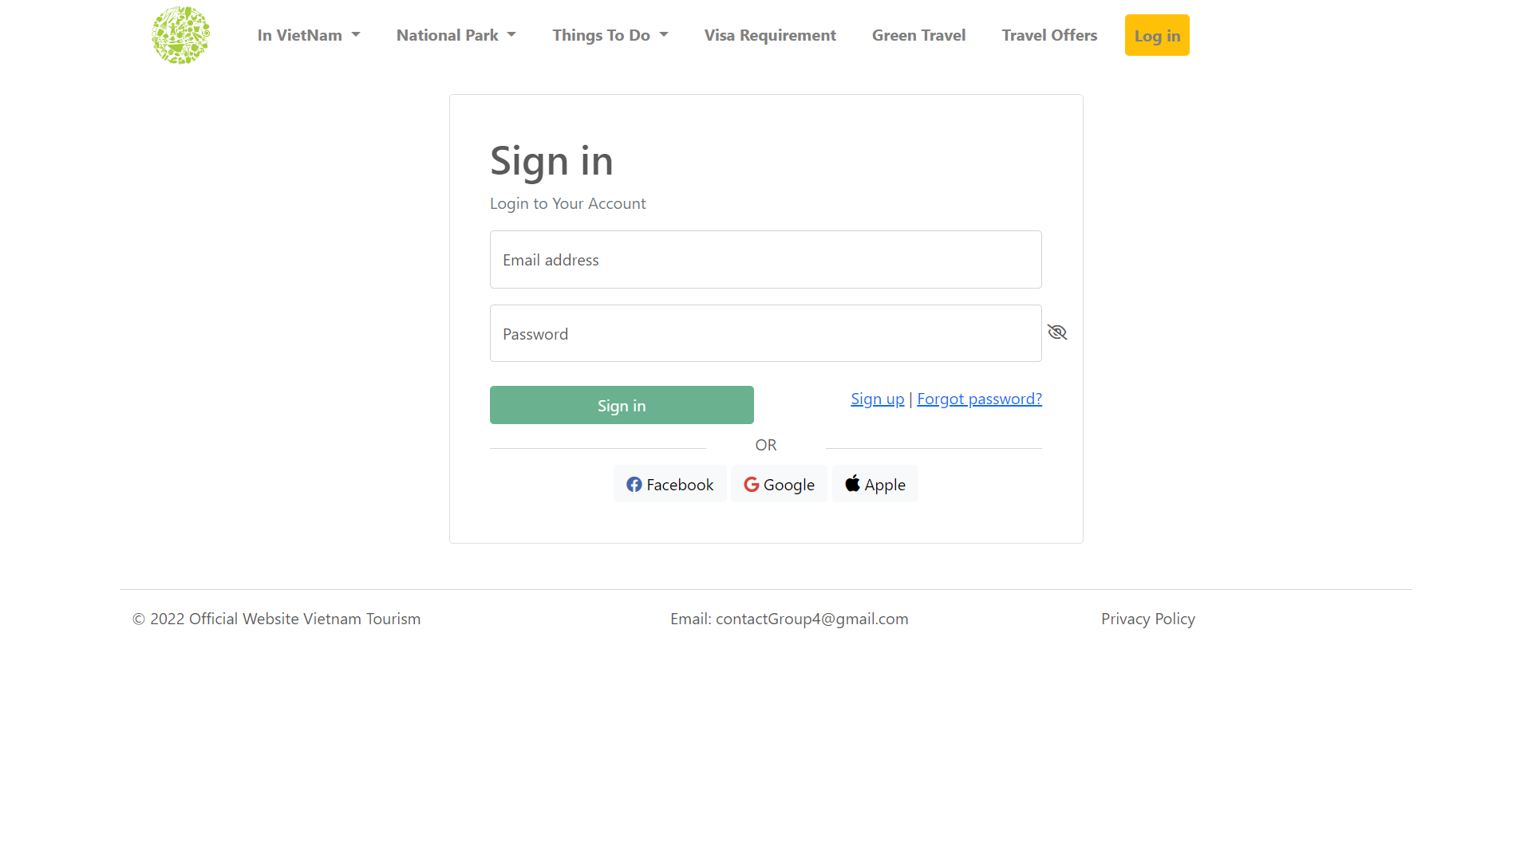

**IX. PROFILE**

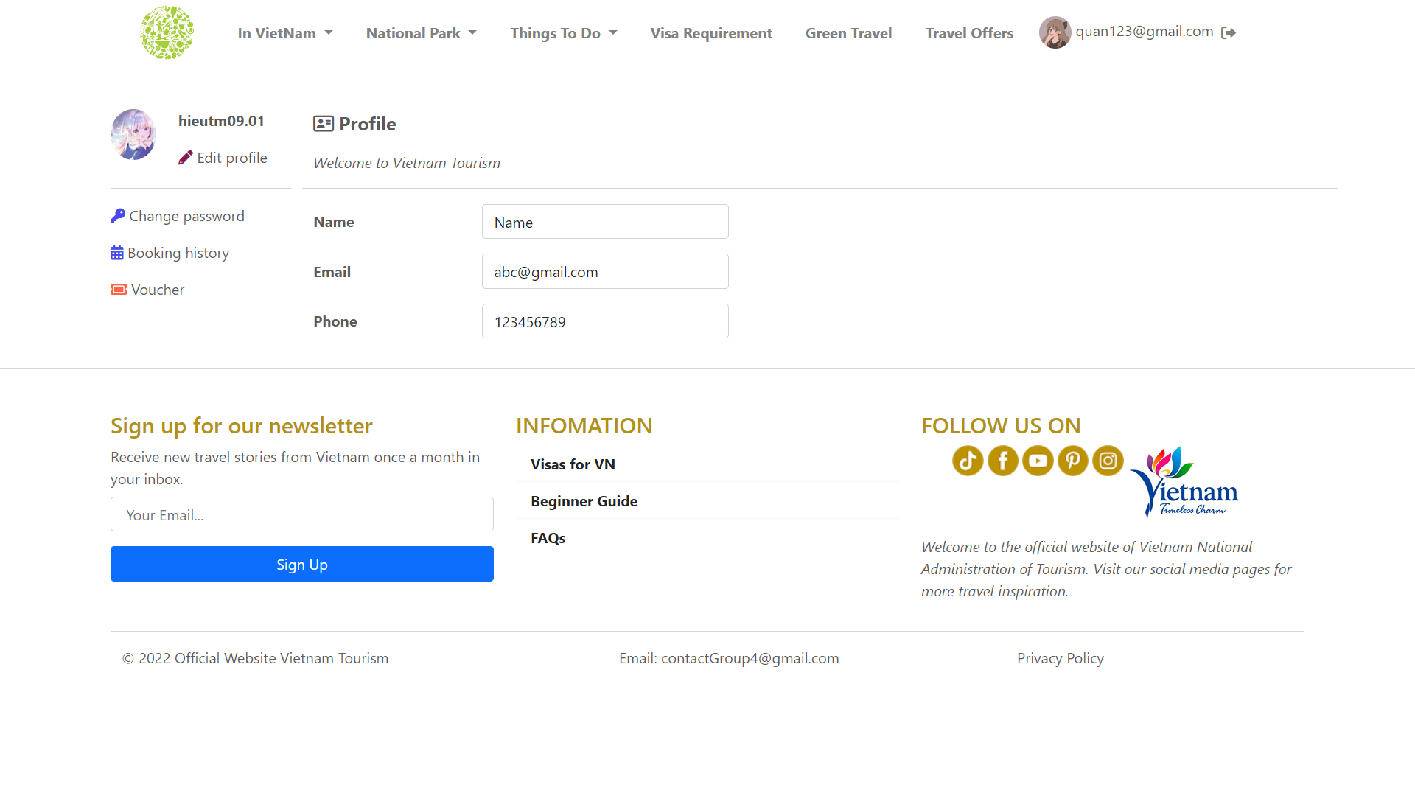

**X. CHANGE PASSWORD**

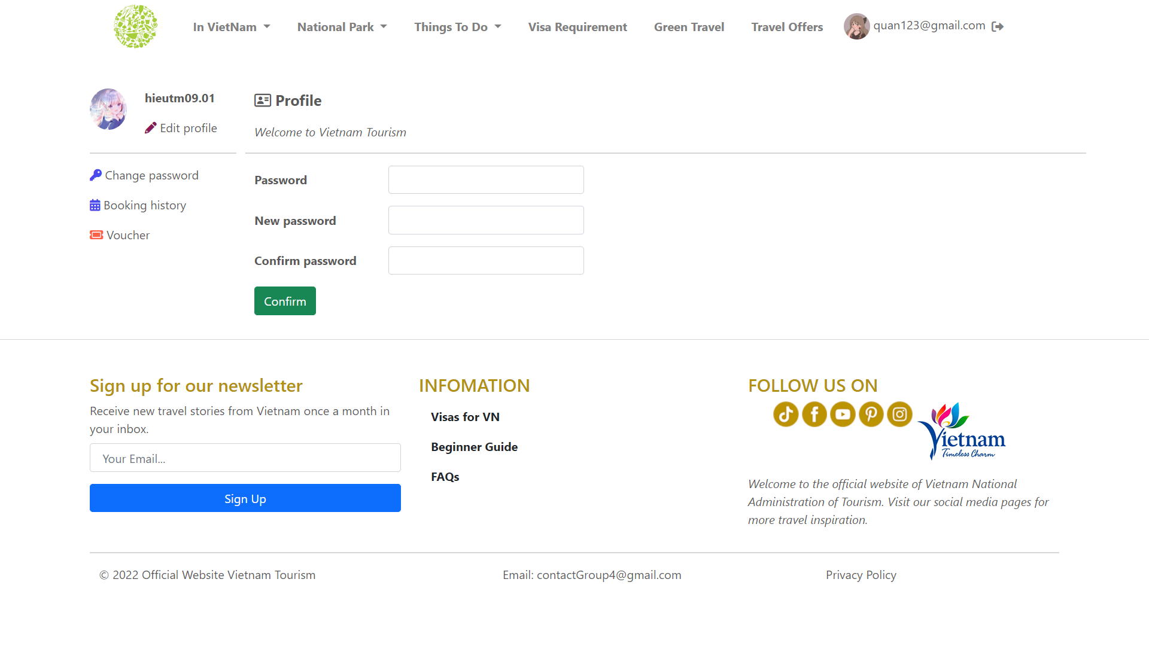

**XI. BOOKING HISTORY**

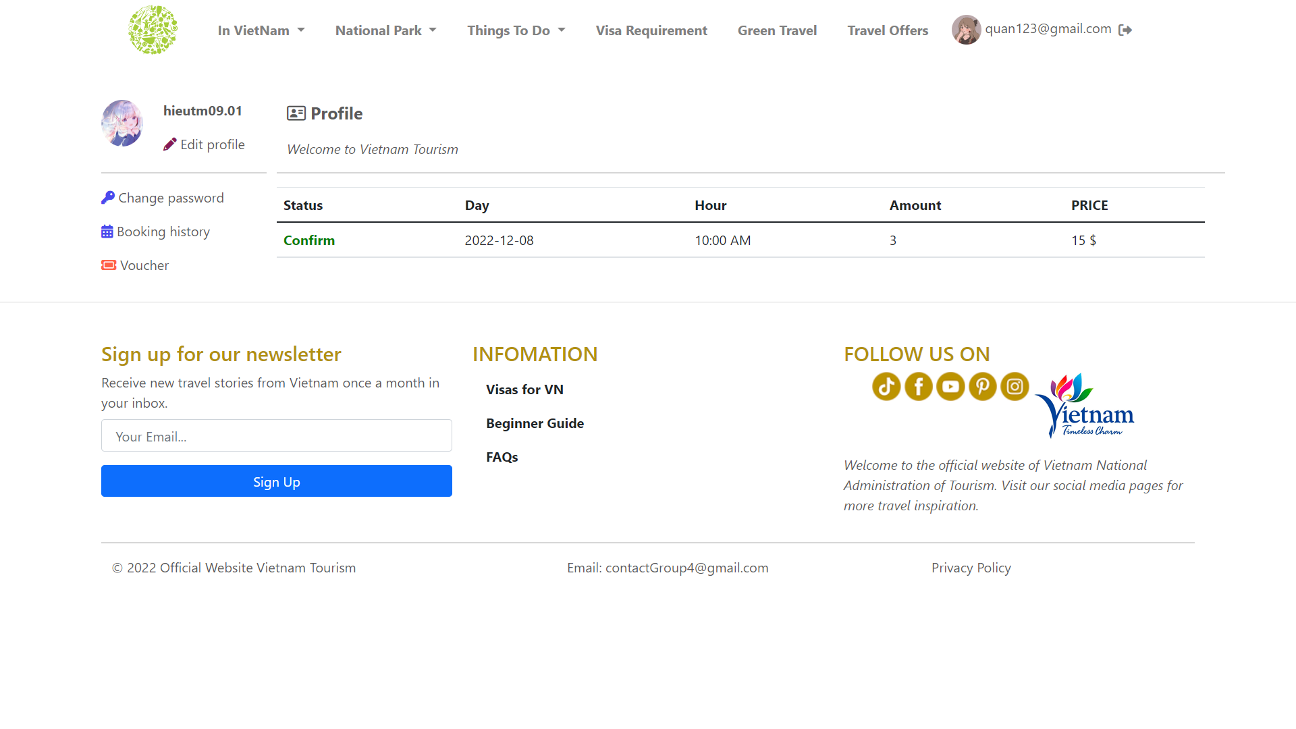

## **Task Sheet**

| **Project Ref No.** | **Project Title – Ask Me Mobile** | **Activity Plan Prepared by** | **Date of preparation of Activity Plan** | | | |
| --- | --- | --- | --- | --- | --- | --- |
| **Task** | **Actual Start Date** | **Actual Days** | **Teammate Names** | **Status** |
| Brainstorming ideas for layouts and Project Object | | Hiếu,  Nguyễn Quân, Hồ Quân | 05/11/2022 | 1 days | Hiếu,  Nguyễn Quân, Hồ Quân | Completed |
| Draw site maps and architecture design | | Hiếu,  Nguyễn Quân, Hồ Quân | 05/11/2022 | 1 days | Hiếu,  Nguyễn Quân, Hồ Quân | Completed |
| Wire framing general page layout | | Hiếu,  Nguyễn Quân, Hồ Quân | 10/11/2022 | 3 days | Hiếu,  Nguyễn Quân, Hồ Quân | Completed |
| Collect static assets (pictures, mp4, documentation,…) | | Hiếu,  Nguyễn Quân, Hồ Quân | 12/11/2022 | 4 days | Hiếu,  Nguyễn Quân, Hồ Quân | Completed |